
NMCD Custody Classification Tool Validation and Misconduct Analysis

Prepared By:
Alex Severson, Ph.D.

Prepared For:
The New Mexico Corrections Department (NMCD)

April 2026

Introduction
Having an effective prison classification process is important for optimizing institutional safety and ensuring that prisons are responsive to inmate needs and to changes in demographics, policy, and resources. Because maintaining institutional safety is a focal concern of correctional institutions (Duwe, 2020; Labrecque, 2022), inmate misconduct is costly (Duwe et al., 2023; Logan et al., 2023), and misconduct in prison predicts recidivism (Logan et al., 2023), it is important to evaluate whether existing classification tools effectively segregate prison populations by misconduct risk (Labrecque et al., 2020; Long, 2020). Validation studies that evaluate predictive performance help provide this understanding (Fazel et al., 2022; Duwe, 2020).
In this report, we present the results of a validation study conducted by the Center for Applied Research and Analysis (CARA) at the University of New Mexico’s Institute for Social Research. Specifically, we extend previous work (Severson et al., 2024; Severson, 2024) that validated NMCD’s existing external custody classification tool and provided recommendations for optimizing its predictive accuracy, in order to evaluate whether the June 3, 2024, revision to NMCD’s classification scoring instruments, which modified item weights and custody level scoring thresholds on both the initial and reclassification scoring forms, affected the tools’ ability to predict inmate misconduct and accurately assign inmates to appropriate custody levels. Our analysis draws on classification and disciplinary data spanning three full years (December 2022 through December 2025), providing an 18-month comparison window centered on the date of the scoring change. By comparing cohorts classified before and after the revision, using identical follow-up periods and outcome measures, we aim to isolate the effect of the instrument change from other longitudinal trends that may have independently influenced misconduct patterns during the study period.
In what follows, we first briefly describe the background of NMCD’s classification system, including the rationale for prison classification and the specific changes the NMCD introduced to both the initial and reclassification scoring tools in June 2024. We then describe the classification instruments themselves, including the custody-level score thresholds, the initial custody scoring form used at intake, and the reclassification scoring form used for periodic reviews, and we highlight structural differences between the two tools. We then describe our study design and methods, including the study population, how we measured misconduct, and the series of statistical methods we used to assess an array of misconduct-related outcomes. We then present findings across several domains: score distributions, override patterns, misconduct rates by custody level, predictive validity, a series of statistical analyses examining post-revision misconduct patterns, classification error rates, and override effectiveness. We conclude the report by offering specific recommendations for the NMCD and by briefly reviewing our main findings.

Background on NMCD Classification
Classification is an important process for separating offender populations based on predictive risk and needs factors. One goal of classification is to make sure that inmates are assigned to facilities and housing units that correspond to their custody level and to separate inmates based on the threats they pose to one another and to correctional staff. Classification processes typically consider factors, such as material, psychological, and relational insufficiencies, that may underlie these risks (Long, 2020).
The NMCD uses both an external and internal classification system. External classification refers to the classification of offenders entering or remaining in the prison system and involves assigning inmates to a facility based on their custody level. Internal classification refers to the system used to determine which cell, housing unit, and programming opportunities (e.g., education, vocational, counseling, and work assignments) inmates are assigned to following external classification. Our present analysis focuses specifically on the initial and reclassification scoring forms of NMCD's external classification system.

Overview of the June 2024 Tool Revisions
On June 3, 2024, NMCD revised its classification scoring instrument, as outlined in Policy CD-081200. The revision modified item weights and scoring thresholds for both the initial custody scoring form and the reclassification scoring form, mostly in ways consistent with the recommendations from our 2024 validation study, with some exceptions (e.g., disparities between CARA’s recommendations and NMCD’s implemented revisions in the lookback period recommendations for the history of institutional violence factor). The central question of this report is whether the changes we proposed to the existing classification instruments were associated with changes in misconduct outcomes. In this report, we compare the association between misconduct and tool scores in the 18 months before the scoring change (i.e., December 2022 - June 2024) to 18 months after (June 2024 - December 2025), using a cohort-based design where each newly classified individual receives a full 183-day (6-month) follow-up window for misconduct measurement.
This report updates our previous validation study (Severson et al., 2024) in a few ways. First, we apply a broader set of statistical methods, including Cox survival analysis, inverse probability of treatment weighting, score-threshold regression discontinuity, interrupted time series with placebo dates, within-person McNemar comparisons, and Pareto/Lorenz concentration analyses, to examine the revision's associations with misconduct from multiple angles. Second, we introduce a reclassification-censoring adjustment to account for NMCD's policy of reclassifying individuals after a guilty misconduct finding, a process that can bias non-adjusted follow-up windows. Third, we also account for time-invariant variation across facilities in their misconduct rates by introducing fixed effects for facilities into our regression-based models.
The June 2024 revision was important because changes to item weights and scoring thresholds can shift how inmates are distributed across custody levels, as suggested by our May 2024 snapshot report (Severson, 2024), which estimated that, if NMCD updated its external custody classification tools to align with our proposed scoring and threshold revisions, then there would be a significant movement of inmates into Level I facilities, though this would also be true if override practices were revised. Even seemingly modest adjustments, such as increasing the maximum score for institutional violence from 8 to 10 points on the reclassification tool or modifying the age scoring brackets, can shift hundreds of individuals across custody-level boundaries (e.g., from Level I to Level II facilities) when applied to the entire classified population. As we flagged in our snapshot report, when large numbers of inmates are reclassified to different custody levels, the practical implications extend beyond individual placement decisions to encompass facility capacity and bed management, staffing requirements at each security level, programming availability and waitlist management, and institutional safety outcomes. For these reasons, it is important to determine whether these distributional shifts improve or degrade the accuracy of the scoring tools (to the extent that it can be causally evaluable), as the answer has direct implications for correctional management and resource allocation.

Classification Instrument Overview

Custody Level Thresholds
Per NMCD Policy CD-081200 (revised 06/03/24), the NMCD classification system uses two scoring tools to assign inmates to different custody levels, one for initial intake assessments and one for reclassification reviews. Both tools produce a total score that maps to custody levels through the scale shown in Table 1. However, before the June 2024 revision, the custody level thresholds were different and varied by sex. The pre-revision initial tool used a range of -1 to 32, while the pre-revision reclassification tool used a range of -7 to 21, both narrower than the post-revision tools' ranges (0 to 37 and 0 to 44, respectively). The pre-revision custody level cutoffs were also sex-specific: for male inmates, Level I = 0 to 5, Level II = 6 to 11, Level III = 12 to 17, Level IV = 18+; for female inmates, Level I = 0 to 6, Level II = 7 to 12, Level III = 13 to 17, Level IV = 18+. The June 2024 revision to the tool unified the sex-specific thresholds into a single scale (0 to 8, 9 to 14, 15 to 20, 21+) applied uniformly across both tools and both sexes, as our 2024 validation analyses did not suggest sex-specific differences in the nature or degree of institutional misconduct, after conditioning on custody level and other factors. This (i.e., having the same cut points for male and female inmates) is a substantive change that could, separate from the item weight changes, impact the distribution of inmates across facilities.
These thresholds between levels establish the framework for all classification decisions. An individual scoring 0 to 8 points is classified as Level I (i.e., minimum custody), representing the lowest assessed risk and qualifying for the least restrictive housing. Scores of 9 to 14 correspond to Level II (i.e., medium custody), 15 to 20 to Level III (i.e., close custody), and 21 or more points to Level IV (i.e., maximum custody). In our May 2024 validation study, we did not find any obvious discontinuities (i.e., jumps) in misconduct rates at specific scoring thresholds or point totals, so the boundaries drawn between custody levels are, in some sense, arbitrary rather than empirically driven by measured natural breakpoints in risk. However, the practical implications of these threshold assignments are important to consider and are a point we revisit later: each custody level corresponds to different facility assignments, housing conditions, supervision intensity, staff-to-inmate ratios, and access to programming. Higher custody levels generally entail more restrictive environments with greater physical security measures, more frequent monitoring, and limited movement, but potentially fewer opportunities for education, vocational training, and community reentry preparation.
Threshold values also changed across periods, with similar apples-to-oranges implications for comparing the misconduct-tool associations between the pre-revision and post-revision levels. Because the revised weights produced a wider score distribution, we proposed raising the Level I cutoff (from 5 to 8 for males; 6 to 8 for females) and the Level IV cutoff (from 18 to 21). While these adjustments were a reasonable response to the expanded score range, they also mean that each custody level potentially captures a somewhat different segment of the population before and after the revision. Because of this, any analysis comparing custody levels across periods needs to account for these threshold shifts alongside the item-weight changes.
Table 1. Current NMCD Custody Level Thresholds [Policy CD-081200 (Revised 06/03/24)]
Level | Score Range
Level I | 0 to 8 points
Level II | 9 to 14 points
Level III | 15 to 20 points
Level IV | 21+ points

Initial Custody Scoring Form (CD-081200.1)
The NMCD’s initial custody scoring form is used for new admissions and for discretionary reviews before the first reclassification. The initial tool contained eight scored factors before the June 2024 revision; the revised tool contains seven factors following the removal of the alcohol/drug abuse item due to its lack of predictive power and concerns surrounding the item’s face validity (i.e., the item claimed to measure drug-alcohol abuse but the wording of the factor did not actually capture drug-alcohol use but rather, trafficking, which while potentially correlated with drug/alcohol abuse, was unknown based on the type of data we received).
The initial custody scoring form is designed to capture the most relevant risk dimensions at the point of entry into the NMCD system. In the pre-revision version of the tool, the tool scored eight factors: history of institutional adjustment and violence with a ten-year lookback (Factor 1, up to 7 points), severity of current conviction (Factor 2, up to 7 points), escape history over the past ten years (Factor 3, up to 7 points), prior felony convictions (Factor 4, up to 3 points), severity of prior convictions (Factor 5, up to 3 points), alcohol/drug abuse (Factor 6, up to 1 point), current age (Factor 7, scored from -2 to +2), and gang membership or activity within the past ten years (Factor 8, up to 2 points). The June 2024 revision made several changes: Factor 6 (alcohol/drug abuse) was removed entirely, the lookback period for institutional violence (Factor 1) and escape history (Factor 3) was reduced from ten years to five and three years respectively given that more recent behavior tends to be a better predictor of future behavior than more distant behavior, and the scoring weight for current age was increased (from a maximum of 2 to 8 points), reflecting empirical evidence that younger age is one of the strongest predictors of institutional misconduct and violent institutional misconduct. In sum, the post-revision initial tool consists of seven factors, with a maximum possible score of 37 points.
A point we raised in our 2024 validation study, and which is important to note to better contextualize findings on predictive validity, is that the initial custody scoring form relies entirely on static or quasi-static risk factors (i.e., fixed characteristics that were established before a given individual’s current period of incarceration). This reliance on pre-existing characteristics is appropriate for initial classification because newly committed individuals likely have no recent institutional behavioral record upon which to base a custody decision. Because of this, the initial tool must use proxies such as criminal history, offense severity, and demographic factors to estimate potential misconduct risk. While these static factors have demonstrated statistical associations with institutional misconduct in prior research (Logan et al., 2023; Labrecque, 2022), they are limited in their ability to capture individual-level propensity for future institutional behavior, which partially may account for why we reported lower levels of predictive validity of the initial tool compared to the reclassification tool in our previous validation study. As an individual develops an institutional track record over time and through behavioral observations (i.e., extended periods of no misconduct), the reclassification tool, which folds in dynamic behavioral measures, becomes the primary classification instrument for ongoing custody decisions.

Table 2. Initial Custody Scoring Form Factors
Factor | Description | Max Points
1 | History of Institutional Violence (5-yr lookback post-revision; was 10-yr pre-revision) | 7 (pre) / 8 (post)
2 | Severity of Current Conviction | 7
3 | Escape History (3-yr lookback post-revision; was 10-yr pre-revision) | 7 (pre) / 6 (post)
4 | Prior Felony Convictions | 3
5 | Prior Conviction Severity | 3
6 | Alcohol/Drug Abuse (pre-revision only; removed June 2024) | 1
7 (pre) / 6 (post) | Current Age (weight increased from max 2 to max 8 post-revision) | 2 (pre) / 8 (post)
8 (pre)/7(post) | Gang Membership/Activity (10-yr lookback) | 2
Note: Maximum possible score: 32 (pre-revision, 8 factors) / 37 (post-revision, 7 factors)

Reclassification Scoring Form (CD-081200.2)
The NMCD’s reclassification custody scoring form is used for 6-month (Level II to IV) and annual (Level I) reviews, and after any guilty misconduct finding. The reclassification tool contains nine scored factors, two more than the post-revision initial tool, which reflects the greater availability of institutional behavioral data for individuals who have been incarcerated for some time.
The factors on the reclassification tool include: history of institutional adjustment and violence (Factor 1, up to 10 points with a five-year lookback), current conviction severity (Factor 2, up to 6 points), escape history over three years (Factor 3, up to 6 points), prior felony convictions (Factor 4, up to 3 points), disciplinary convictions received within the past 24 months (Factor 5, up to 11 points), history of disciplinary misconduct or clear conduct (Factor 6, scored from -3 for 36+ months of clear conduct to 0 for no clear conduct), program and work performance (Factor 7, scored from -2 for maximum good time to 0), current age (Factor 8, scored from -2 to +2 in the pre-revision and from -2 to +8 in the post-revision), and gang membership or activity (Factor 9, up to 2 points). The most notable differences from the initial tool are Factor 5, which replaces the measure of prior conviction severity with a dynamic behavioral measure of recent institutional misconduct, and the inclusion of Factors 6 and 7, which reward sustained clear conduct and satisfactory program participation by deducting scores. These features make the reclassification tool directly responsive to an individual's behavior while incarcerated, meaning custody levels can flex up or down depending on whether a given individual’s behavioral patterns improve or deteriorate.
The reclassification tool’s maximum possible score of 44 points exceeds the initial tool’s maximum of 37 points, primarily because Factor 1 (institutional violence) can contribute up to 10 points (versus 8 on the initial tool), and Factor 5 (disciplinary convictions) can contribute up to 9 points. This expanded scoring range allows for greater differentiation among individuals with extensive or severe institutional behavioral histories, and these point totals, specifically on the institutional violence history and age factor, were increased due to their observed association with misconduct and serious violent misconduct reported on in our validation study. The reclassification instrument is administered at regular intervals, every six months for Level II through Level IV inmates and annually for Level I inmates, as well as following any guilty misconduct finding, which triggers an immediate reclassification review. This periodic and event-triggered reassessment schedule helps make sure that custody levels are responsive to changing behavioral patterns, allowing individuals who demonstrate sustained good conduct the opportunity to step down to lower custody levels while reclassifying those who continue to engage in misconduct to higher security levels.
Table 3. Reclassification Scoring Form Factors
Factor | Description | Max Points
1 | History of Institutional Adjustment and Violence (5-yr lookback) | 10
2 | Severity of Current Conviction | 6
3 | Escape History (3-yr lookback) | 6
4 | Prior Felony Convictions | 3
5 | Disciplinary Convictions Received (past 24 months) | 11 (pre) / 9 (post)
6 | History of Disciplinary Misconduct/Clear Conduct | -3 to 0
7 | Program and Work Performance | -2 to 0
8 | Current Age (weight increased from max 2 to max 8 post-revision) | 2 (pre) / 8 (post)
9 | Gang Membership/Activity | 2
Note: Maximum possible score: 44 (post-revision, 9 factors)

Study Design and Methods

Study Population
Our study population includes 6,594 unique individuals classified during the study window (i.e., December 3, 2022, through December 3, 2025). Understanding who is being classified matters because if the types of people being classified changed between periods (i.e., if the post-revision period included younger or higher-risk inmates), these compositional changes alone could explain any pre-post misconduct differences, independent of the scoring revision per se. We more explicitly evaluate the potential for compositional differences in the prison population across periods to explain subsequent differences in comparing patterns of misconduct in the subsequent Population Composition Check subsection of the current report.
Our sample is mostly male (86.5%; n = 5,704). We found that the sample concentrated in the 25–34 (35.0%; n = 2,308) and 35–44 (34.5%; n = 2,275) age brackets, which together accounted for nearly 70% of individuals, while those under 25 (7.7%; n = 505) and 55 and older (7.9%; n = 520) each made up a considerably smaller share. This age distribution is relevant to the validation analysis because age is one of the strongest and most consistent predictors of institutional misconduct found both within our 2024 analyses and other peer-reviewed work; younger inmates tend to engage in more misconduct across virtually all correctional settings (Logan et al., 2023), and we previously found in our 2024 validation study that age was the factor most predictive of general and serious violent misconduct, after statistically controlling for all other scoring item factors. Because of this, any shifts in the age composition between the pre- and post-revision periods could confound naïve, unadjusted pre-post comparisons between the two periods, making it important to statistically adjust for age in our analyses. Similarly, the sex composition matters because male and female inmates may have different baseline misconduct rates and may respond differently to the classification instrument’s risk factors, though findings from our 2024 analysis did not suggest meaningful sex-based differences in misconduct (which was one of the motivations for not retaining the sex-specific scoring differential).
Of the 22,212 total classification events in the study period, 20.5% (n = 4,555) were initial classifications and 79.5% (n = 17,657) were reclassifications. Because the initial and reclassification tools have different scoring structures, factor compositions, and maximum possible scores (37 versus 44 points) and because their predictive performance may also differ for reasons we have outlined (i.e., the initial tool relies entirely on static pre-incarceration factors while the reclassification tool incorporates dynamic behavioral data through Factor 5), our primary analyses in this report examine initial and reclassification tools in isolation.
Within the study window, individuals had a median of 3 classification events (mean = 3.4, range 1 to 14), with 20.7% classified only once and 25.4% classified four or more times. The average individual received 0.7 initial classifications and 2.7 reclassifications during the study period. A total of 3,023 individuals (45.8%) were classified in both the pre-revision and post-revision periods.
Table 4. Characteristics of the Study Population
Characteristic | Value
Total N (unique persons) | 6,594
Gender
Female | 890 (13.5%)
Male | 5,704 (86.5%)
Age
18-24 | 505 (7.7%)
25-34 | 2,308 (35.0%)
35-44 | 2,275 (34.5%)
45-54 | 986 (15.0%)
55-64 | 390 (5.9%)
65+ | 130 (2.0%)
Classification Events (n=22,212)
Initial | 4,555 (20.5%)
Reclassification | 17,657 (79.5%)

Measuring Misconduct
We used a cohort-based design: the denominator is each newly classified individual, and every person receives a full 183-day (six-month) follow-up window regardless of when the scoring revision occurred. We measured three outcomes: (1) any guilty misconduct finding within six months following classification, (2) any serious (Class A) misconduct (guilty) within six months following classification, and (3) any serious violent (guilty) misconduct within six months following classification. We chose a six-month follow-up period because the NMCD reclassifies inmates every six months or upon a guilty misconduct finding, except for Level I inmates and those with a Special Management designation, who are reclassified annually.
We measured misconduct as follows. Any misconduct was defined as any guilty finding on a disciplinary report during the follow-up period, regardless of severity class. Serious misconduct was defined as any guilty finding on a Class A violation, which includes offenses such as possession or use of dangerous drugs (A18), refusal to submit to a drug test (A17), fighting (A39), threats (A14), possession of drug paraphernalia (A16), refusal to move or to be restrained (A32), tattooing or possession of tattoo paraphernalia (A30), and possession of dangerous contraband (A20). Serious violent misconduct was defined as any guilty finding on a Class A violation that involved physical violence or the threat of imminent physical harm, including fighting (A39), assault or battery without a weapon on an inmate (A8) or on staff or visitors (A7), assault or battery with a weapon (A6), battery (A5), engaging in or inciting a riot (A9, A10), arson (A4, A1C), murder (A1), taking of hostages or kidnapping (A3), robbery or extortion (A23), rape or sexual assault (A22, A1G), and escape with force (A11). Other misconduct (Class B and C violations) includes offenses such as disobeying a lawful order (B16), presence in an unauthorized restricted area (B9), failure to follow published rules (B33), failure to program (B5), and verbal abuse or gestures (B14).
We use two analytic samples throughout this report. We use all non-overridden classification events in which the custody level recommended by the scoring tool matches the final custody level placement, with standard errors clustered by individual to account for non-independence of repeated observations (i.e., two classification records from the same person tend to look more alike than two records drawn from different people, so treating them as independent observations would understate uncertainty). Our adjusted analyses (i.e., logistic regression, survival analysis, interrupted time series) use this same non-overridden sample, which isolates the tools’ predictive performance from the effects of staff discretion or override policy and is the only sample on which to evaluate the tools’ predictive performance. The non-overridden analytic sample consists of 9,647 classification events from 3,573 unique individuals over the 18-month period. Because individuals may contribute multiple classification events, all inferential analyses use cluster-robust standard errors (clustered on individual) to account for within-person correlation.
The 183-day follow-up window introduces what is called right-censoring for individuals released or transferred before the window closes (i.e., their observation period ends before the full 183 days pass, meaning any misconduct that might have occurred after that point is unobserved). To address this, individuals whose release date or projected release date fell before the end of the 183-day follow-up period were excluded from all analyses (n = 1,315, representing approximately 28.3% of the eligible non-overridden classifications). This exclusion ensures that all individuals in the analytic sample (N = 3,339) had the opportunity to be observed for the full follow-up duration. We also included the remaining sentence length (i.e., days from classification to projected release) as a standardized covariate in regression models to statistically adjust for any residual association between time-at-risk and misconduct probability.

Results

Executive Summary of Key Metrics
In Table 5, we present a set of frequencies comparing the use of overrides and misconduct rates by level before and after the tool revisions. Before the scoring change, the total override rate across both tools was 59.5%; after the revisions to the tool and to policy, it was 56.8%. As CARA and the New Mexico Legislative Finance Committee (LFC) have noted in prior reporting, this is a particularly high override rate for a risk assessment tool; most people should be placed at the custody level that makes sense without manual adjustment. The fact that mandatory overrides decreased post-revision aligns with some of our policy recommendations from our validation study. However, the use of discretionary overrides increased between the pre- and post-revision periods, which suggests that classification staff were more frequently choosing to override the tools’ recommendations.
Pooled across custody levels, the 6-month any‑misconduct rate decreased from the pre‑revision to the post‑revision period, from 47.7% to 41.6% among non‑overridden classifications, a statistically significant drop (χ²(1) = 28.2, p < .001). The level-specific increases at Levels I and IV were more than offset by the growth of the Level I population (where misconduct was lower than the system average) and by declines at Levels II and III. Pooled across all four levels, the serious‑violent rate also declined, from 12.2% to 10.7% (χ²(1) = 4.27, p = .039).
Table 5. Override Prevalence and 6-Month Misconduct Rates, Pre-Revision vs. Post-Revision (18-Month Symmetric Window)
Metric | Pre-Revision | Post-Revision
Total override rate | 59.5% | 56.8%
Mandatory override rate | 50.2% | 38.3%
Discretionary override rate | 10.7% | 22.4%
% any misconduct (6mo) - Pooled | 47.7% | 41.6%
% serious violent misconduct (6mo) - Pooled | 12.2% | 10.7%
% any misconduct (6mo) - Level I | 19.8% | 29.2%
% any misconduct (6mo) - Level II | 49.3% | 42.8%
% any misconduct (6mo) - Level III | 55.9% | 48.4%
% any misconduct (6mo) - Level IV | 39.4% | 50.8%
% serious violent misconduct (6mo) - Level I | 4.0% | 5.8%
% serious violent misconduct (6mo) - Level II | 13.0% | 13.1%
% serious violent misconduct (6mo) - Level III | 14.3% | 11.5%
% serious violent misconduct (6mo) - Level IV | 14.2% | 14.8%

At Level I, the misconduct rate increased from 19.8% to 29.2%, a 9.1 percentage-point increase. However, it is important to note that this occurred alongside a near-tripling of the Level I population from 276 to 810 individuals. Before the revisions to the NMCD custody classification policy in June 2024, many individuals scored at Level I but were overridden into higher custody levels; the revised scoring and changes in policy retain more of these individuals at their scored level, meaning the post-revision Level I cohort could include some who carry slightly elevated risk profiles compared to the smaller, more selectively placed pre-revision group. Level III saw a decrease in the misconduct rate from 55.9% to 48.4%, a 7.5 percentage-point reduction. Level IV experienced the largest percentage-point change, with misconduct rising from 39.4% to 50.8%, an increase of 11.4 percentage points.
Important to note is that none of the pre‑post increases in serious violent misconduct at the custody‑level reached statistical significance (Level I: χ² = 3.40, p = .065; Level II: p = .59; Level IV: p = .84). Level III showed a marginal decrease (p = .067). Pooled across all four levels, the serious‑violent misconduct rate also declined, from 12.2% to 10.7% (χ²(1) = 4.27, p = .039). The modest level-specific upticks, therefore, do not reflect a systemwide increase in serious violent behavior; both any misconduct and serious violent misconduct moved downward on balance.
A notable feature of the pre-revision distribution was that the Level IV misconduct rate (39.4%) was lower than the Level III rate (55.9%). While a strictly monotonic gradient, where each successive custody level shows higher misconduct than the one below, is not necessarily expected (given that the more restrictive conditions and reduced opportunities for misconduct at higher-security facilities can suppress observed rates independently of underlying risk), the magnitude of this reversal was difficult to attribute to environmental factors alone. The post-revision rates produce a more orderly gradient, with each successive level showing progressively higher misconduct, consistent with improved risk differentiation, even though some degree of non-monotonicity could be expected on theoretical grounds (i.e., higher securitization at higher-custody-level facilities may mechanically reduce the odds of misconduct).
These patterns suggest that the revisions to the tools more effectively differentiate risk across custody levels, though the relationship between custody level and observed misconduct is shaped by both individual risk and the environmental constraints of each security setting. Serious violent misconduct rates follow a broadly consistent pattern: Pre-Revision rates were 4.0%, 13.0%, 14.3%, and 14.2% for Levels I through IV, while post-revision rates are 5.8%, 13.1%, 11.5%, and 14.8%. Inmates in Level IV facilities had the highest serious violent misconduct rate in both periods, consistent with the tools’ concentration of higher-risk individuals at the highest custody level.

Score Distributions
In this section, we explore whether and how score distributions shifted following the revision. Because the revised instrument changed both item weights and the thresholds that define custody-level tipping points, shifts in the score distribution do not necessarily correspond to proportional shifts in custody-level placements, and the two must be interpreted together. Because of this, the score distributions are purely descriptive/informational.
Table 6. Score Distribution By Tool Type and Period (Non-Overridden)
Period | Tool Type | N | Mean | SD | Median | Min | Max
Pre-Revision | Initial | 361 | 8.1 | 4.3 | 8 | -1 | 23
Pre-Revision | Reclassification | 2,269 | 11.9 | 5.5 | 13 | -4 | 28
Post-Revision | Initial | 890 | 6.9 | 4.5 | 6 | 0 | 24
Post-Revision | Reclassification | 4,991 | 14.1 | 6.9 | 15 | -2 | 32

For non-overridden reclassifications, the average total score shifted from 11.9 (pre) to 14.1 (post), a change of +2.2 points. For non-overridden initial classifications, the average total score shifted in the opposite direction, from 8.1 (pre) to 6.9 (post), a decrease of 1.2 points. These differing patterns are noteworthy because they indicate that the scoring revision had opposite effects on the two tools. The increase in reclassification scores is largely driven by the expanded age weighting (i.e., the maximum increased from 2 to 8 points), while the decrease in initial classification scores reflects the removal of the alcohol/drug abuse item and possibly reduced lookback periods for violence and escape history. However, because custody-level thresholds also changed across periods, these score shifts do not directly translate into predictable changes in custody-level placement. For example, a higher average reclassification score, does not necessarily push more individuals into higher custody levels since the cutpoints separating those levels also increased.
Figure 1. Total Score Distributions By Period and Tool Type
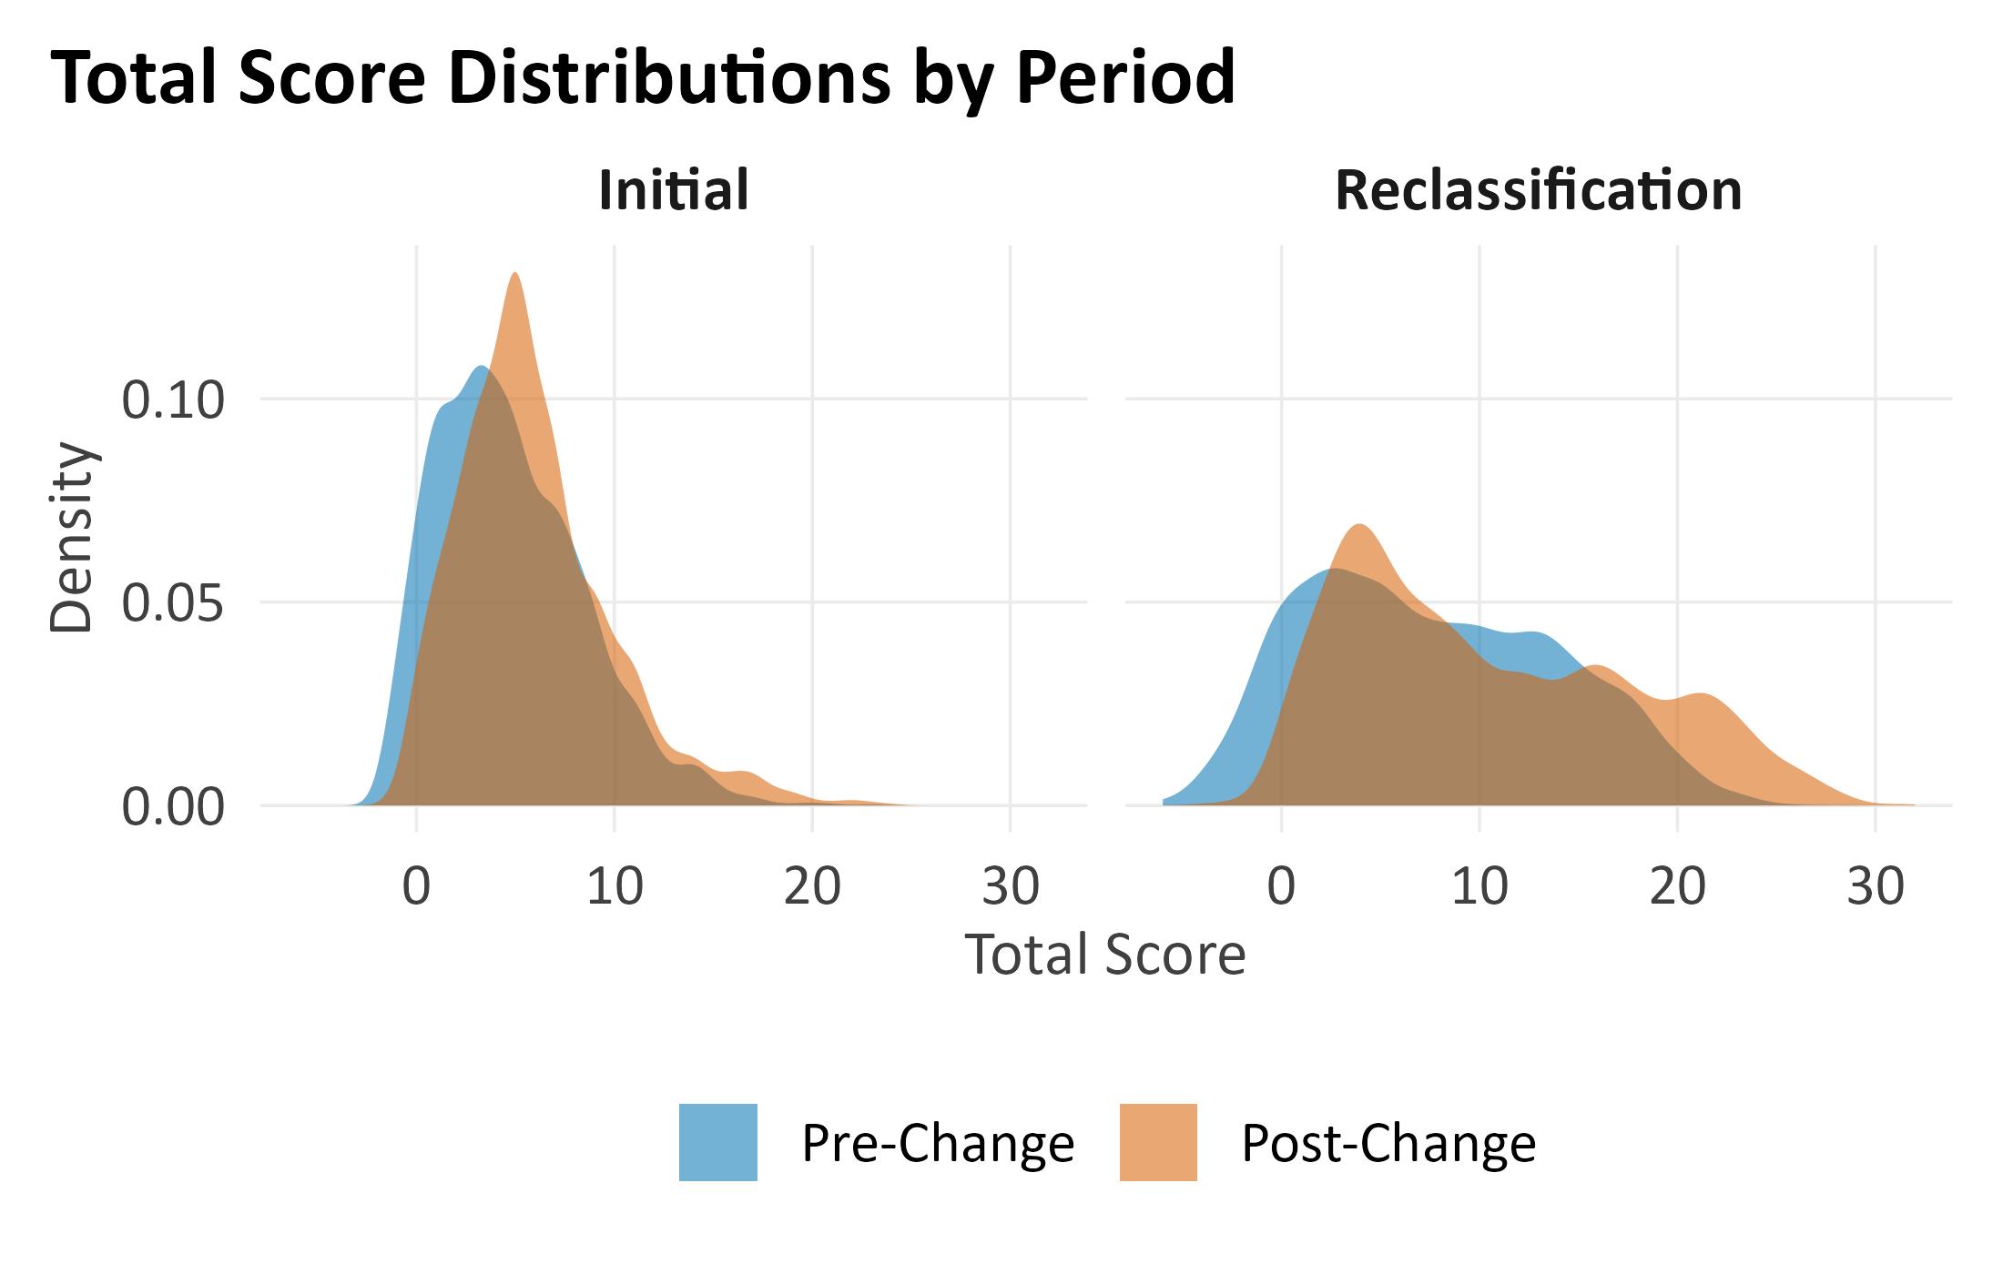

Population Composition Check
Before interpreting any difference in misconduct between periods, it is important to evaluate whether the pre- and post-revision populations are comparable across observed characteristics. One common way to quantify how comparable two groups are on a given characteristic is the standardized mean difference (SMD), which is essentially the gap between the two group averages expressed in units of that characteristic's normal spread. This rescaling is useful because it allows us to judge imbalance across variables measured on very different scales (e.g., age in years vs. a yes/no gang-affiliation flag) using the same benchmark. By convention, an SMD exceeding |0.10| indicates a meaningful imbalance, and values above |0.25| indicate a substantial imbalance that could confound pre-post comparisons in misconduct rates.
We examined seven observed characteristics: total classification score, proportion male, proportion with a violent current conviction (i.e., Factor 2 scoring the current offense as violent, not institutional violent misconduct), any mental health designation, defined as a documented mental health acuity code of 1 or higher, serious mental health (defined as acuity level 3 or higher, corresponding to moderate-to-severe psychiatric need), age at classification, and proportion that were initial classifications (vs. reclassifications). Of these, three exhibited moderate or near-moderate imbalance between periods: total classification score (SMD = 0.218), proportion male (SMD = −0.106), and mental-health-any (SMD ≈ 0.10). The total-score imbalance is mechanical rather than a confound, because the June 2024 revision changed how scores are computed. Stated differently, a shift in the score distribution is an expected consequence of the implementation of scoring revisions, not a pre-existing population difference requiring adjustment.
The remaining four characteristics (i.e., violent current conviction, serious mental health, age, and initial classification) show acceptable balance (|SMD| < 0.10). The meaningful imbalances that could confound pre-post comparisons were limited to the proportions of males and those with any mental health designation. The adjusted analyses we use in subsequent sections (i.e., logistic regression and survival analysis) address these by statistically controlling for sex, mental health status, and the other observed covariates. Any misconduct difference that remains after adjustment is more likely associated with the period itself, while any difference that reduces the degree of difference was likely driven by who is being classified rather than the tool change.
Our population balance assessment considers only observed characteristics, those that are measured and available in the data. It is important to flag a limitation of this, though; there may be unobserved differences between the Pre-Revision and post-revision populations (e.g., changes in substance use patterns, cognitive functioning, or external stressors) that are not captured by the seven measured characteristics and the data we had access to for purposes of this analysis, which may correlate with misconduct rates. While the adjusted analyses cannot fully account for unobserved confounders, the fact that four of the seven measured characteristics show acceptable balance, and that the remaining imbalance is driven by a mechanical change in the total score itself, provides some reassurance that the two populations are broadly comparable on the pre-intake factors we can measure. The convergence of multiple analytical methods on similar conclusions further reduces, but does not outright eliminate, the concern that unmeasured confounding is driving the results.
Figure 2. Population Balance Between Periods (Standardized Mean Differences)
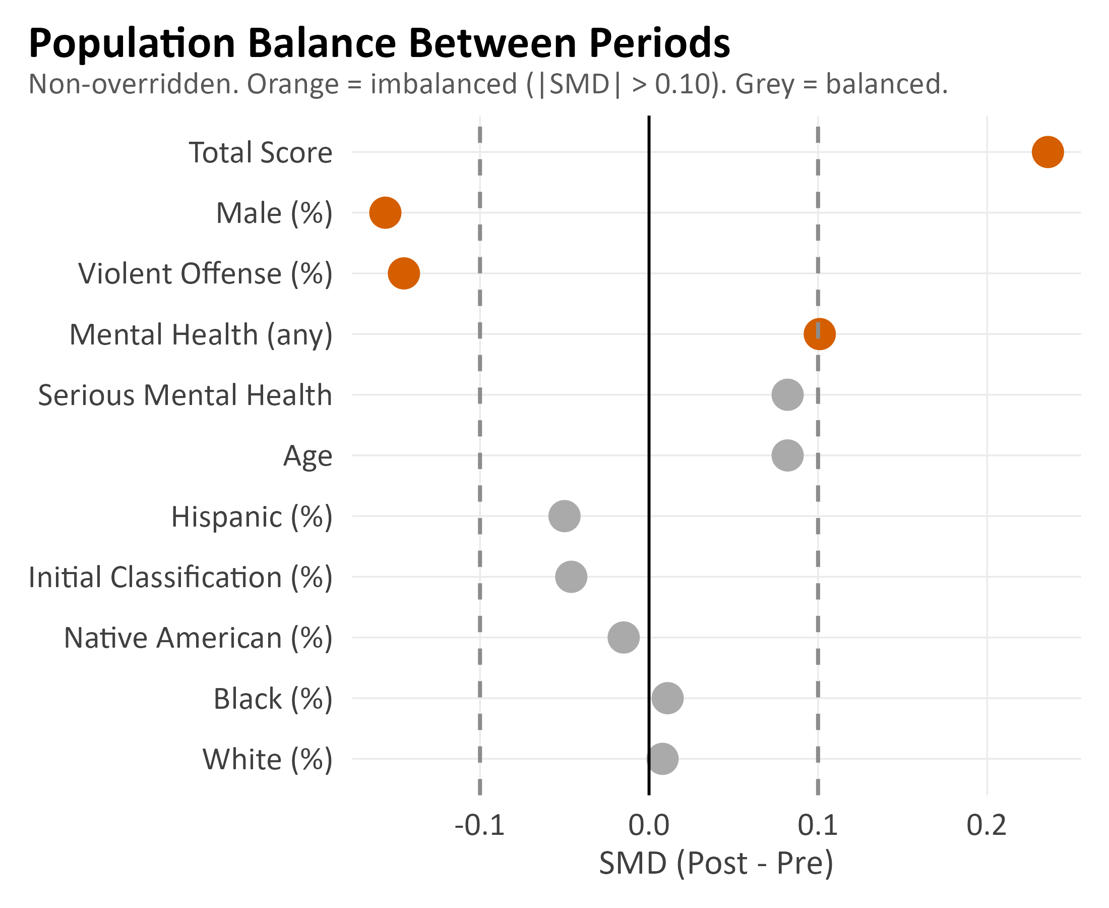

Misconduct by Custody Level
A well-functioning classification tool should generally sort individuals so that higher custody levels house individuals with a higher risk of misconduct. In practice, however, the relationship between custody level and observed misconduct is not purely a function of individual risk. Higher custody levels typically entail more restrictive housing, heightened surveillance, and reduced movement and programming access, all of which could, in principle, suppress opportunities for misconduct independently of a given individual’s underlying risk, though it is also possible that there are monitoring effects pushing in the opposite direction (i.e., heightened surveillance at higher custody levels increases opportunities for prison staff to observe misconduct). Because of this, observed misconduct rates across levels reflect a combination of risk sorting and differences in environmental exposure. With that caveat in mind, a pattern in which the highest custody level has lower misconduct than a lower level may still raise questions about classification accuracy, particularly when the magnitude of the inversion is large.
Across both periods combined, misconduct rates by final custody level are 26.6% (Level I), 46.6% (Level II), 53.7% (Level III), and 43.4% (Level IV). The gradient increases from Level I through Level III but shows an inversion at Level IV, a pattern driven primarily by the pre-revision period (see the period-stratified rates in Table 9).
Table 9. % of Inmates By Level Engaging In Misconduct By Period
Final Level | Period | N |  | % Any | % Serious | % Serious Violent | p (pre vs post)
Level I | Pre-Revision | 545 |  | 19.6 | 13.4 | 4.0 | any p<.001; ser p=.006; SV p=.088
Level I | Post-revision | 1,642 |  | 29.2 | 19.8 | 5.8
Level II | Pre-Revision | 1,724 |  | 49.3 | 33.9 | 13.0 | any p=.005; ser p=.906; SV p=.630
Level II | Post-revision | 1,393 |  | 42.8 | 32.8 | 13.1
Level III | Pre-Revision | 1,724 |  | 55.9 | 36.0 | 14.4 | any p<.001; ser p=.054; SV p=.026
Level III | Post-revision | 1,225 |  | 48.4 | 35.0 | 11.5
Level IV | Pre-Revision | 564 |  | 39.4 | 30.5 | 14.1 | any p<.001; ser p=.245; SV p=.906
Level IV | Post-revision | 830 |  | 50.8 | 35.9 | 14.4

To test whether an upward gradient is present in the data rather than just visible by eye, we ran three complementary statistical tests and report results separately for the initial tool, the reclassification tool, and the pre- and post-revision periods. The Cochran-Armitage trend test asks whether there is any upward trend across the four levels. The Jonckheere-Terpstra test assesses whether a randomly selected individual from a higher level is more likely to have engaged in misconduct than one from a lower level. An ordinal logistic regression estimates how much the odds of misconduct increase for each one-level step up in custody. Using three tests rather than one helps distinguish a genuine gradient from a pattern driven by a single unusual level.
The reclassification tool passes all three tests in both the pre- and post-revision periods, with every test reaching statistical significance with p < 0.001. The post-revision reclassification tool produces a gradient in which every level sits above the one below, with no inversions. The pre-revision tool was close but not perfect, with the Level IV inversion noted above. The initial tool tells a weaker story. The ordered comparison test detects a trend in both periods, but only marginally (p = .042 pre-revision, p = .036 post-revision), and the trend test is not statistically significant pre-revision (p = .389) and only borderline post-revision (p = .051). This does not mean the initial tool is ineffective, as higher custody levels still average higher misconduct, but the separation between adjacent levels is small enough that random noise or variability could plausibly account for some of the difference. This weaker performance is consistent with what we would expect from a classification tool that relies entirely on fixed intake information, without any record of more recent, observed institutional behavior. The reclassification tool, which incorporates a dynamic behavioral item (i.e., recent disciplinary history), has an inherent predictive advantage in this respect.
Ordinal logistic regression provides a measure of gradient strength. Across the four combinations of tool and period, the odds ratios range from approximately 1.13 (initial tool, pre-revision) to 1.50 (reclassification tool, pre-revision). More specifically, moving an individual up one custody level on the reclassification tool is associated with roughly a 30 to 50% increase in their odds of a misconduct finding, while the same step on the initial tool is associated with a smaller 13 to 25% increase. These are aggregate statistical summaries rather than individual-level predictions, but they converge on the same broad finding: the reclassification tool separates risk groups substantially better than the initial tool, and the revised scoring preserved that separation.
Chi-square tests of pre-vs-post proportions within each level (which we reported in the right-hand column of Table 9) reveal a few more points worth commenting on. The Level I increase in any and serious misconduct is statistically significant (p < .001 and p < .01), though the difference in serious violent misconduct is not. Similarly, the Level III decrease in any misconduct (p < .001) and the Level IV increase in any misconduct (p < .001) are statistically significant.
Two findings at Level III are particularly notable. First, Level III housed the largest volume of individuals in both periods, yet its misconduct rate declined by 7.5 percentage points from 55.9% to 48.4%. Second, Level III shows the largest reduction in serious violent misconduct (p = .077), dropping from 14.3% to 11.5%. No other level experienced a statistically significant change in serious violent misconduct between periods. Together, these patterns suggest that the revised scoring may have shifted some of the highest-risk individuals out of Level III and into Level IV, reducing the concentration of serious violence in what had been the most populated custody level.
Another finding is that, in the pre-to-post comparison, the Level IV inversion in the misconduct rate from Level III is corrected. In the pre-revision period, Level IV had a 39.4% misconduct rate, lower than the 55.9% rate at Level III. While environmental suppression at higher security levels may account for some degree of non-monotonicity, the magnitude of this reversal (22 percentage points below Level III) was difficult to attribute to environmental factors alone. Under the revised scoring, Level IV misconduct rose to 50.8%, producing a monotonic gradient. This shift is consistent with the revised item weights and thresholds, which more effectively concentrate higher-risk individuals at Level IV. The pre-revision inversion may have occurred because the old weighting scheme captured individuals with high static risk scores (such as serious conviction histories or lengthy criminal records) who did not necessarily translate that background risk into institutional misconduct, while underweighting characteristics that better predicted actual behavioral problems within the institution.
Figure 3. 183-Day Misconduct Rate By Custody Level and Period
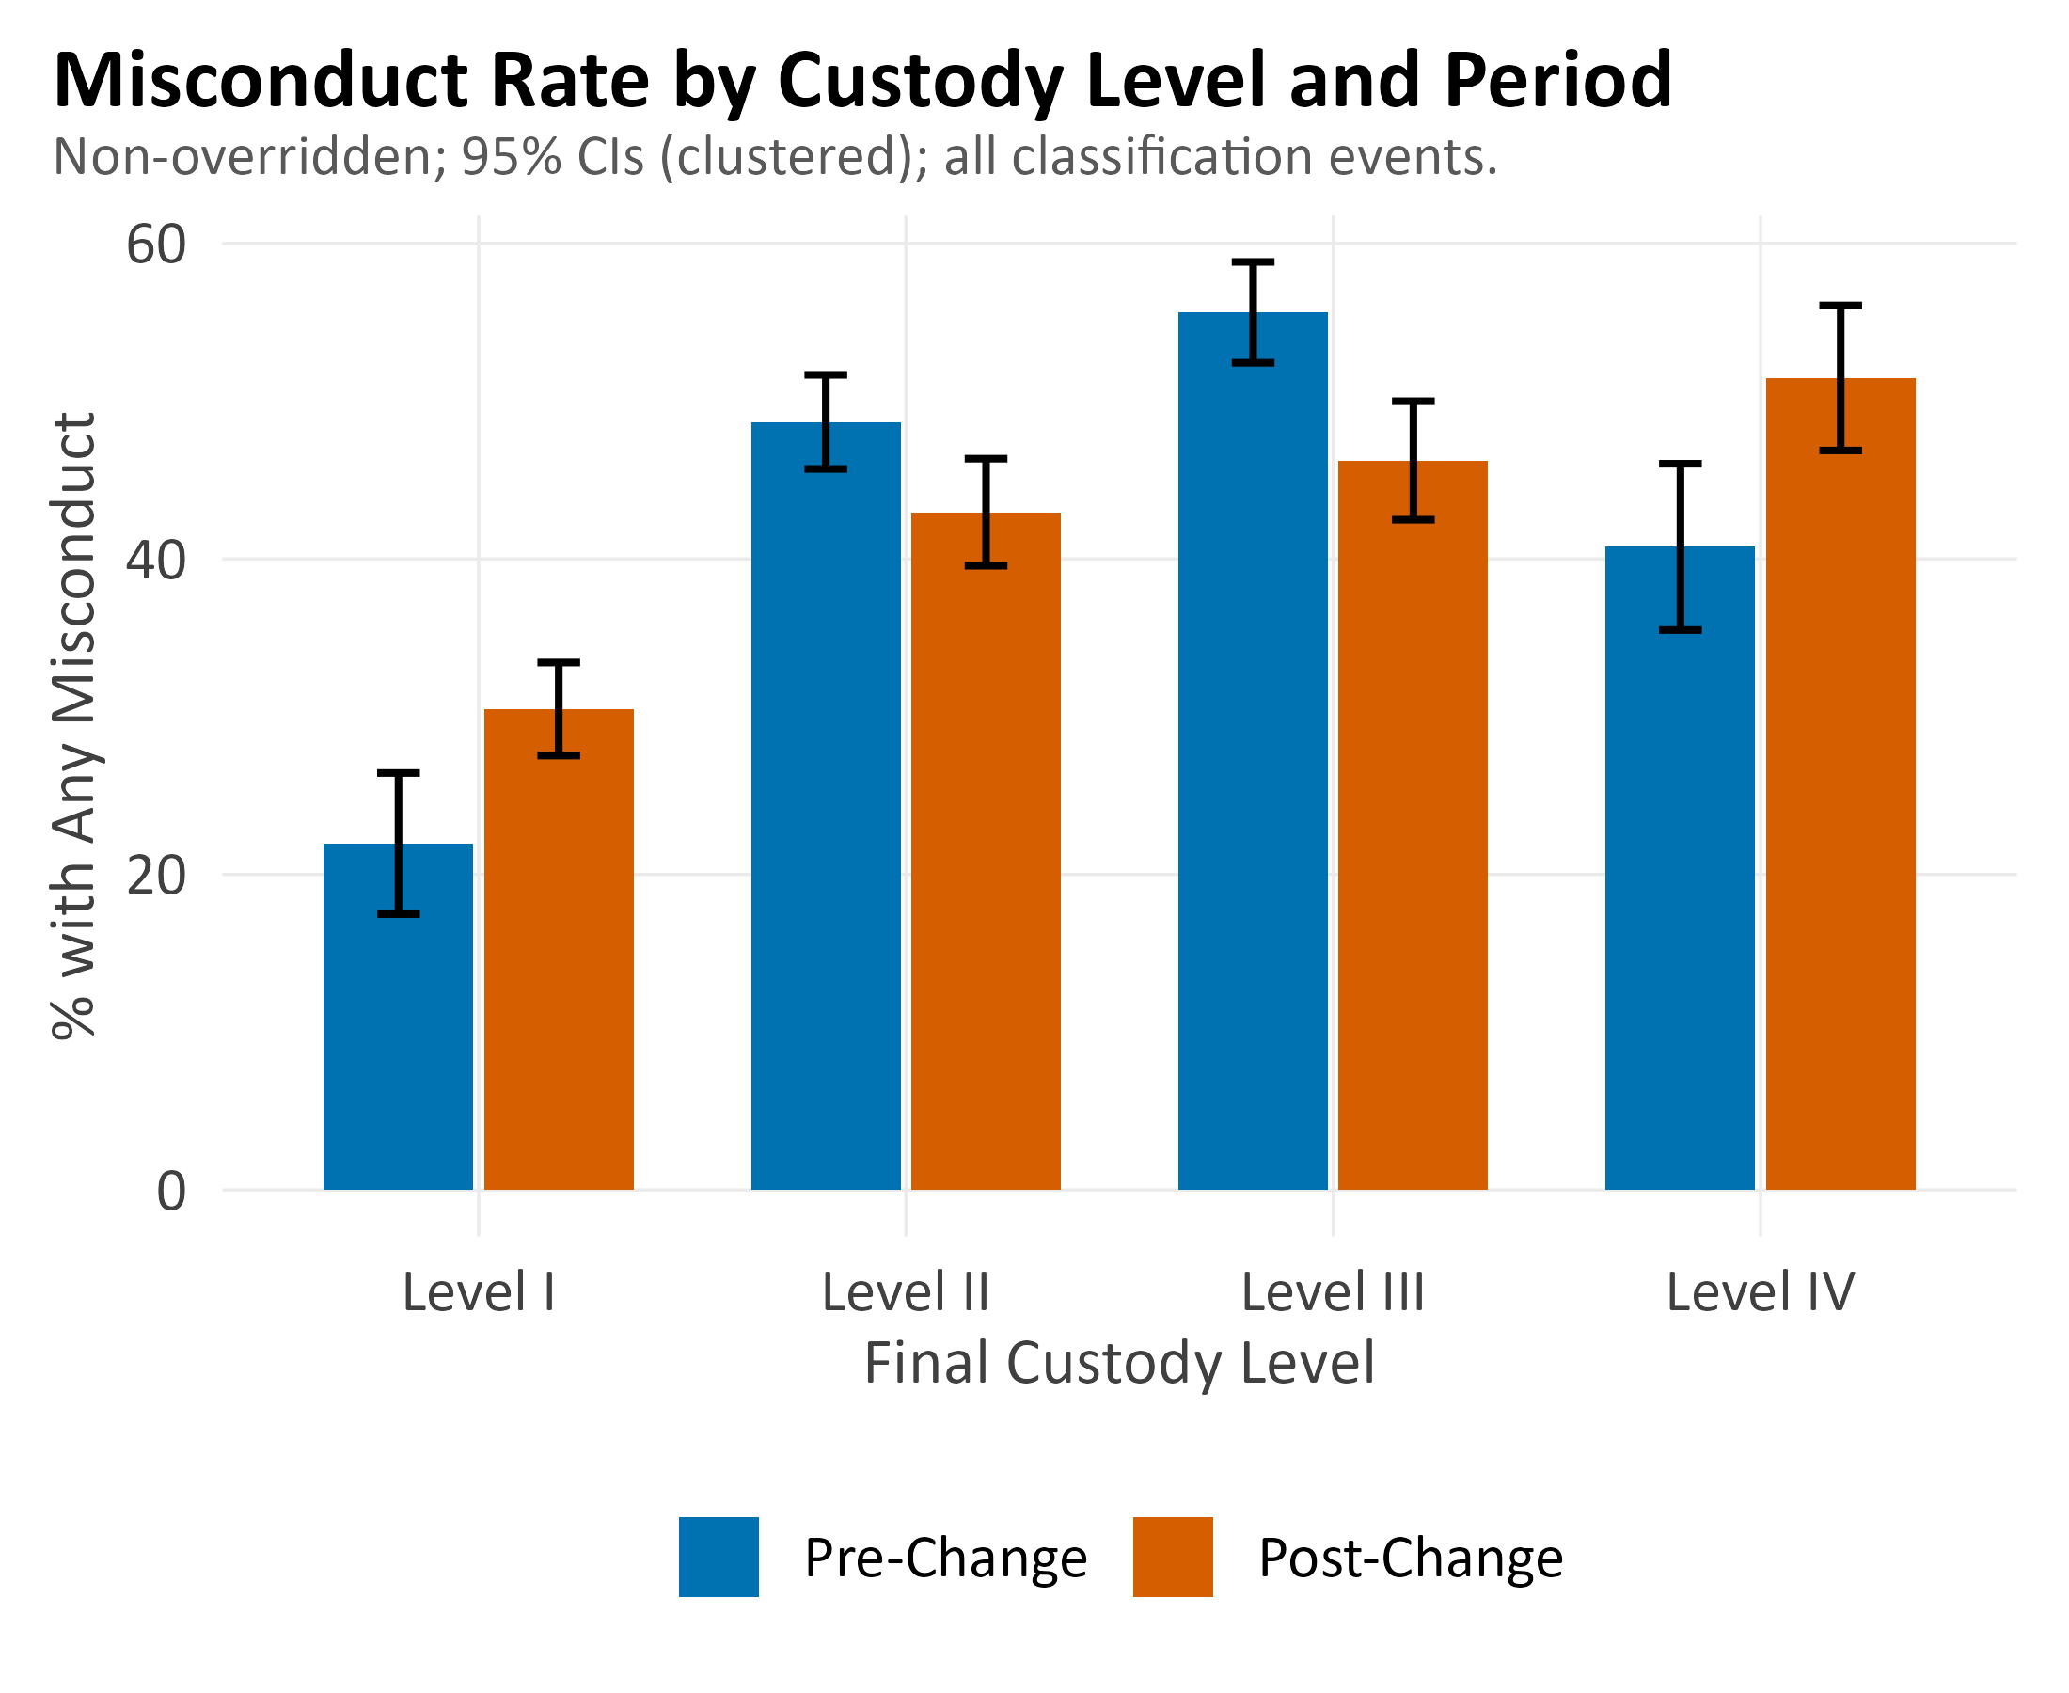
Note. Error bars show 95% Wilson confidence intervals. Analysis truncated at June 2025 to ensure full 183-day follow-up.
In Figure 4, we present the same custody-level misconduct gradient shown in Figure 3, stratified by sex, so that male and female inmates can be examined separately. This view matters for three reasons. First, the pooled gradient in Figure 3 averages across a sample that is roughly 87% male, potentially obscuring sex-specific patterns important for operational planning at facilities housing women. Second, the NMCD eliminated sex-specific custody-level thresholds in the June 2024 revision in line with our recommendations, so it is relevant to ask whether male and female inmates at the same custody level experience similar misconduct rates; systematic differences would suggest that the unified thresholds are better calibrated for one sex than the other. Third, the cohort of female inmates has substantially smaller cell sizes, so the wider confidence intervals in the female panel are a direct visual reminder that pre-/post-comparisons within the female Level IV should not be over-interpreted.
From Figure 4, we observe that the male population exhibits the gradient reported in Figure 3: Level I has the lowest misconduct rate, the middle levels rise progressively, and Level IV sits at or near the top in the post-revision period. The Pre-Revision Level III-to-Level IV inversion is also visible here. The female cohort shows a steeper overall gradient, with Level IV misconduct ranging from 65 to 70% in both periods, higher than any male cell, though the confidence intervals are wide enough that the pre-to-post difference at female Level IV is not statistically significant. Female Levels I through III follow the same rank order as the male panel, and the post-revision rates are broadly similar to pre-revision rates within each female level. Taken together, Figure 4 suggests that the unified post-revision thresholds do not appear to systematically misclassify women relative to men, as the within-sex gradients are structurally similar. That said, the small female Level IV cell produces wide confidence intervals, limiting the precision of any conclusions for the highest-custody women.
Figure 4. 183-Day Misconduct Rate By Custody Level (Supplemental View)
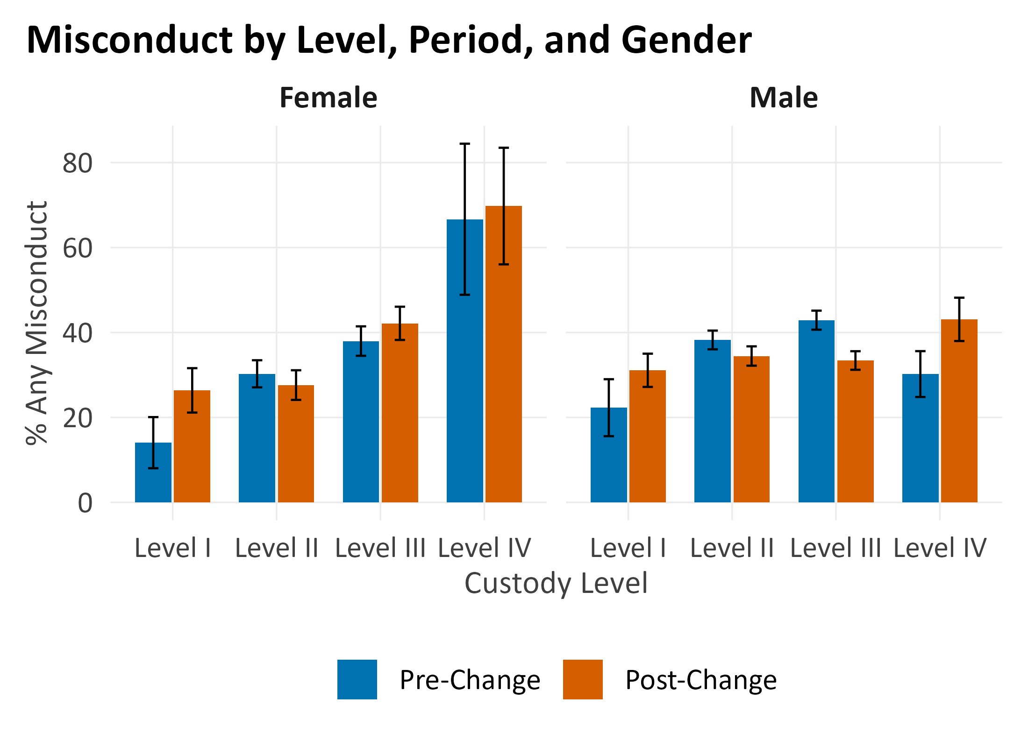

Level I Misconduct Deep Dive
The Level I misconduct increase, from 19.8% in the pre-revision period to 29.2% in the post-revision period, warrants attention because Level I is the least restrictive custody classification, reserved for individuals for which the custody classification tool flags as presenting the lowest institutional risk. In what follows, we briefly discuss some analyses that help to clarify the nature, causes, and implications of this increase.
The most important context for the proportion of inmates at Level I engaging in misconduct is the expansion of the Level I population. The number of individuals classified and placed as Level I nearly tripled, from 545 in the pre-revision period to 1,642 in the post-revision period. For initial classifications specifically, the Level I share grew by 30.5 percentage points, while the reclassification share grew by 13.2 percentage points. This expansion reflects two concurrent changes: the revised scoring weights, which produce lower total scores for many individuals and place them within the Level I range (i.e., 0 to 8 points), and a reduction in the use of mandatory overrides for medical and mental health reasons, which previously moved many individuals out of Level I regardless of their Level I placing tool score. Because of this, the expanded Level I population includes individuals who, under the old tool scoring or mandatory override practices, would have been classified at Level II or higher.
Score distribution analysis at the Level I-Level II point boundary confirms that this expansion is not limited to a handful of borderline cases. Among the 1,310 non-overridden Level I individuals in the post-revision period, 18.1% (n = 237) had scores of 7 or 8, within one point of the Level I ceiling. These individuals sit at the upper edge of the Level I range and would need only a small scoring change to fall into Level II. If these boundary-adjacent individuals have higher misconduct rates than those scoring well below the ceiling (0 to 6), that compositional shift could explain part of the overall Level I increase without indicating a problem with the classification system. We revisit this discussion more in the Regression Discontinuity subsection which specifically statistically tests for local changes in misconduct around the point boundaries of level cutoffs.
The types of violations committed by Level I individuals also help to provide important context (see Table 10). In the post-revision period, the five most common Level I violation types were failure to follow published rules or regulations (248 events), refusal to submit to a drug test (221), fighting (132), presence in an unauthorized restricted area (130), and possession or use of dangerous drugs (127). While fighting is a violent offense, the proportion of Level I individuals involved in at least one fighting incident did not change significantly between the Pre-Revision and post-revision periods (2.6% vs. 4.5%, χ²(1) = 2.50, p = .11), suggesting that the absolute rise in fighting events at Level I reflects the growth of the Level I population itself rather than an increase in individual-level propensity to fight. The predominance of rule-compliance violations, drug-related infractions, and unauthorized movement further suggests that much of the Level I misconduct increase reflects challenges with institutional adjustment and substance use rather than serious violence. The Pre-Revision Level I violation profile was qualitatively similar but at much lower absolute volumes due to the smaller population, with drug test refusal (80 events) and possession or use of dangerous drugs (53) leading the list.
Table 10. Level I - Top 10 Infractions (Ranked By Total Events)
Infraction | Pre-Revision n (%) | Post-revision n (%) | Total
Refusal to Submit to a Drug Test [A17] | 80 (16.2%) | 221 (11.5%) | 301
Failure to Follow Published Rules or Reg [B33] | 36 (7.3%) | 248 (13.0%) | 284
Possession or Use of Dangerous Drugs [A18] | 53 (10.7%) | 127 (6.6%) | 180
Fighting [A39] | 33 (6.7%) | 132 (6.9%) | 165
Presence In Unauthorized Restricted Area [B9] | 27 (5.5%) | 130 (6.8%) | 157
Possession of Drug Paraphernalia [A16] | 35 (7.1%) | 88 (4.6%) | 123
Failure to Program [B5] | 28 (5.7%) | 94 (4.9%) | 122
Disobeying Lawful Order [B16] | 19 (3.8%) | 81 (4.2%) | 100
Threats [A14] | 11 (2.2%) | 74 (3.9%) | 85
Tattooing and/or Possession of Tattoo Pa [A30] | 19 (3.8%) | 60 (3.1%) | 79
All guilty misconduct events in window | 494 (100%) | 1,915 (100%) | 2,409
Note: 'n' is the count of guilty findings (not unique individuals). Percentages are within-period shares (column n divided by the period's total guilty findings). Denominators differ from event counts reported elsewhere in the main report when those figures use a different cohort specification.
The proportion of Level I individuals with serious mental health designations (i.e., having an MH flag with acuity level 3 or higher) more than doubled between periods, from 9.9% to 30.1%. This increase was particularly pronounced for initial classifications, where the rate rose from 10.8% to 35.8%. This shift is consistent with the reduced use of mandatory mental health overrides noted above: individuals who would previously have been overridden out of Level I due to their mental health status are now remaining at Level I, changing the composition of the Level I population. Among non-overridden Level I individuals, those with serious mental health designations had a misconduct rate of 35.0%, compared to 25.1% for those without. In the fully adjusted logistic regression model within Level I, serious mental health status was a significant independent predictor of misconduct (OR = 1.61, p = .001), confirming that mental health burden contributes to misconduct risk beyond what the classification score captures.
Override patterns among young inmates (i.e., inmates under age 26) also provide additional context. Under the pre-revision initial tool, 52.7% of these inmates scored into Level I based on the tool alone. However, classification staff overrode 70.5% of them upward, leaving only 2.4% of young inmates placed at Level I after overrides. The June 2024 revision expanded the age item's scoring range, increasing the absolute and proportionate weight age, relative to other scoring factors, carried in the total score. In focus groups conducted with NMCD classification officers after the proposed scoring revisions, officers reported concerns that the revised tool was classifying young inmates as Level II largely based on their age score, prompting discretionary downward overrides to compensate for what they perceived as an unfair penalty for youth. These override patterns suggest an inherent tension between the tool’s treatment of age as a risk factor and staff judgment about appropriate placement for younger inmates, a conversation we revisit more in the Overrides subsection.
Finally, the regression discontinuity analysis at the Level I/Level II boundary (score 8 vs. 9) found no statistically significant jump in misconduct rates at the threshold (effect = -0.036, p = .670), indicating that the cutoff falls along a smooth risk gradient rather than at a natural breakpoint in behavior. Other threshold analyses show that lowering the Level I ceiling from 8 to 6 points would modestly improve the separation between Level IV and Level I misconduct rates (from a ratio of 1.51 to 1.64) and reduce the Level I misconduct rate from 29.1% to 26.4%.

Predictive Validity (AUC)
As discussed in our 2024 validation report, the AUC (Area Under the ROC Curve) is a standard metric for evaluating whether a classification tool predicts who will commit misconduct. An AUC of 0.50 means the classification tool performs no better than chance; an AUC of 1.00 would mean perfect prediction. In more concrete terms, an AUC of 0.60 means that if we randomly selected one person who committed misconduct and one who did not, the scoring tool would correctly assign a higher score to the person who committed misconduct 60% of the time. Interpretations of AUC thresholds vary across the risk-assessment literature. Following Desmarais and Singh (2013), values below 0.55 are considered poor, 0.55 to 0.63 fair, 0.64 to 0.71 good, and 0.71 or higher excellent. Other conventions are somewhat more permissive; Fazel et al. (2022), for example, treat AUCs between 0.60 and 0.70 as acceptable and values above 0.70 as good. No single cutoff is universally endorsed, so AUCs should be interpreted in context alongside base rates, calibration, and the consequences of misclassification.
In Table 11, we present AUCs with 95% confidence intervals for the total score predicting each misconduct outcome, by tool type and period, restricted to non-overridden classifications.

Table 11. Predictive Validity (AUC) By Tool Type and Period
Tool | Period | Any Misconduct | Serious | Serious Violent
Initial | Pre-Revision | 0.595 [0.547, 0.643] | 0.577 [0.528, 0.626] | 0.555 [0.490, 0.621]
Initial | Post-revision | 0.582 [0.537, 0.627] | 0.591 [0.542, 0.640] | 0.632 [0.566, 0.698]
Reclassification | Pre-Revision | 0.561 [0.538, 0.583] | 0.559 [0.536, 0.582] | 0.583 [0.546, 0.620]
Reclassification | Post-revision | 0.624 [0.602, 0.646] | 0.604 [0.580, 0.628] | 0.606 [0.570, 0.642]

Two patterns are worth noting. First, the reclassification tool consistently outperforms the initial tool for any misconduct (AUCs of 0.605-0.637 versus 0.575-0.597). This is expected because the reclassification tool incorporates institutional behavior history, information that is unavailable at intake for first-time prison admissions. The reclassification tool also shows improvement across all outcomes post-revision, approaching statistical significance for any misconduct (DeLong, p = .052) and for serious misconduct (DeLong, p = .070). Second, the initial tool shows the largest single improvement between periods for serious violent misconduct (AUC rising from 0.558 to 0.625, DeLong p = .102), suggesting that the revised initial scoring better identifies inmates at risk for the most serious outcomes. None of the within-tool pre-to-post differences reach conventional levels of statistical significance, but the directional pattern is consistent across outcomes.
Table 11. AUC By Gender (Total Score and Score-Based Level Predicting Any Misconduct)
Group | Pre N | Post N | Pre AUC (Score) | Post AUC (Score) | Pre AUC (Level) | Post AUC (Level)
Male | 3,916 | 3,842 | 0.543 | 0.588 | 0.587 | 0.606
Female | 641 | 1,248 | 0.645 | 0.689 | 0.578 | 0.614

Figure 5 visualizes these results as ROC curves, where a curve that bows further toward the upper-left corner indicates better predictive performance. At any point on a curve, the x-axis shows the false positive rate (i.e., the share of individuals flagged as high risk who did not go on to commit misconduct) and the y-axis shows the true positive rate (i.e., the share of individuals who committed misconduct who were correctly flagged as higher risk). The diagonal dashed line represents chance performance (AUC = 0.50), equivalent to a coin flip; curves that bow above the diagonal perform better than chance, and the area under each curve (AUC) summarizes that overall separation in a single number. The curves in Figure 5 sit only modestly above the diagonal, consistent with the small-to-moderate AUC values reported in Table 19.

Figure 5. ROC Curves: Total Score Predicting 183-Day Misconduct By Period and Tool Type
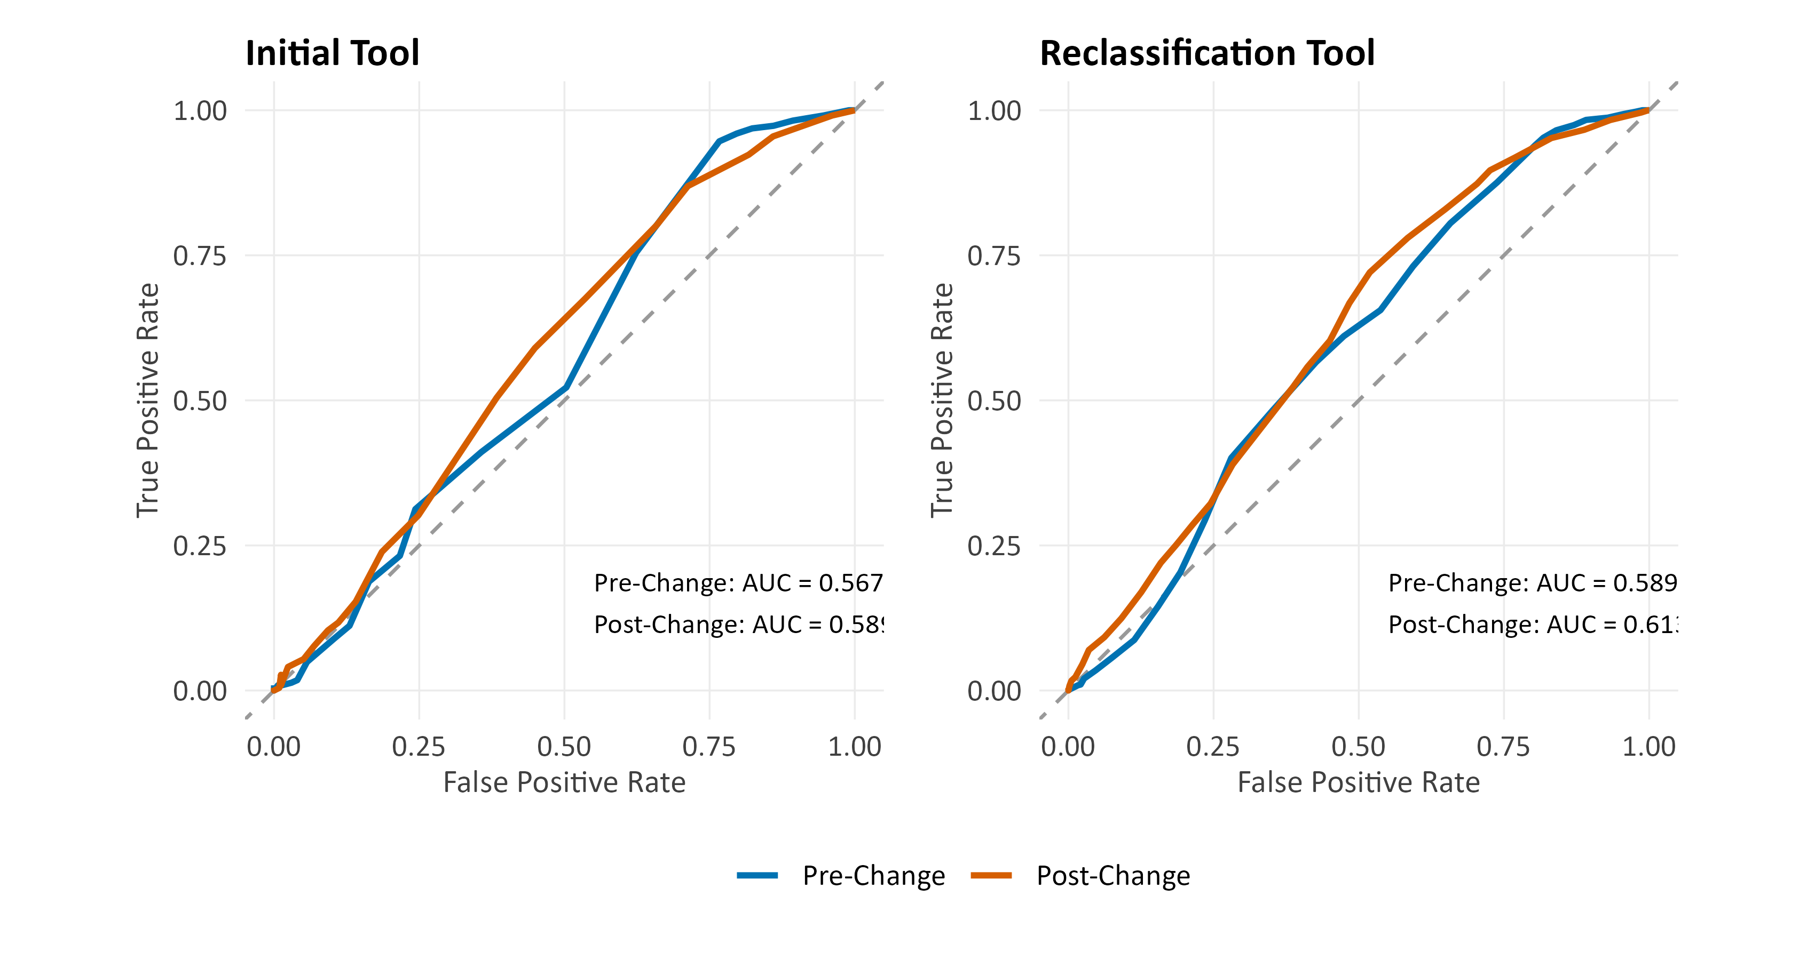

Item-Level Predictive Validity
As with our 2024 validation study, we also wanted to explore which items on the tools were most predictive of misconduct after statistically controlling for other factors. Figures 6 and 7 report item-level AUCs separately for each tool, and Figure 8 places the two side by side on a common scale for direct comparison. Taken together, the three figures show which items carry predictive weight on each tool, how their relative importance differs between the two tools, and whether that importance changed after the June 2024 revision.

Figure 6. Corrected Item-Level AUC Values (Initial Tool)
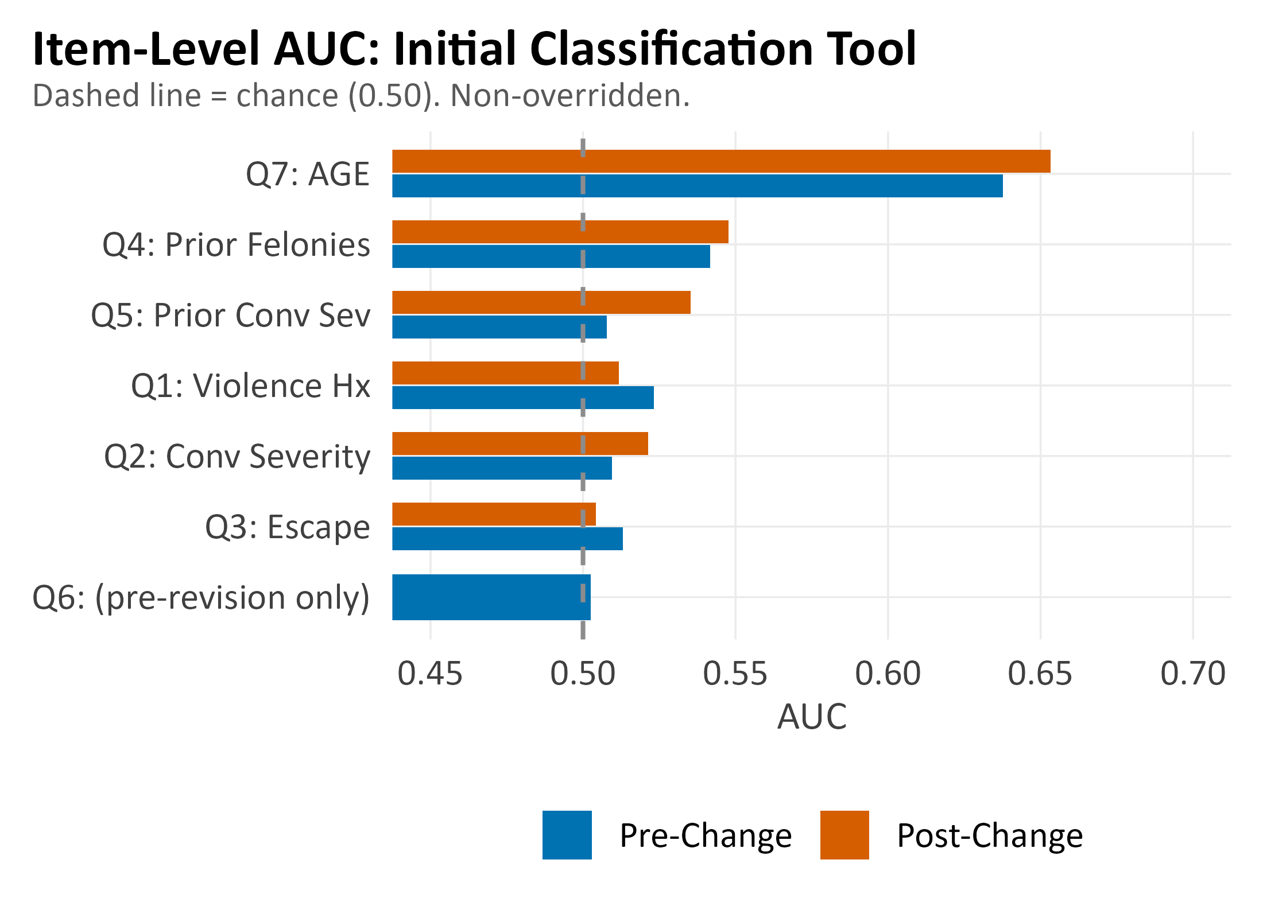
Findings from the item-level AUC analysis reveal that the strongest predictors differ by tool. On the initial classification tool, age is by far the single strongest predictor (Q7 AUC = 0.651 post-revision), outperforming every other item by a substantial margin. On the reclassification tool, the lead shifts: institutional disciplinary history (Q5) becomes the top item (AUC = 0.600 post-revision), narrowly edging out age (Q8, AUC ≈ 0.595). This tool-specific difference is partly by design. Age carries less scoring weight on the reclassification tool than it does on the initial tool, reflecting a deliberate policy choice to give more weight to in-custody behavior once a person has been observed in the system, rather than relying predominantly on the static demographic and criminal-history variables that dominate the initial tool. As a result, even though the item-level AUC for age remains moderately above chance on both tools, the contribution of age to the overall composite score is smaller in reclassifications than it is at initial classification. Using the actual continuous age variable rather than the scored item yields AUCs of 0.625 for any misconduct and 0.627 for serious violent misconduct, indicating that age remains a useful risk signal throughout the classification system, and that, on its own, it predicts serious violent misconduct at least as well as general misconduct, though its concrete influence on a person's assigned level depends on which tool is being applied.

Figure 7. Item-Level AUC Values (Reclassification Tool)
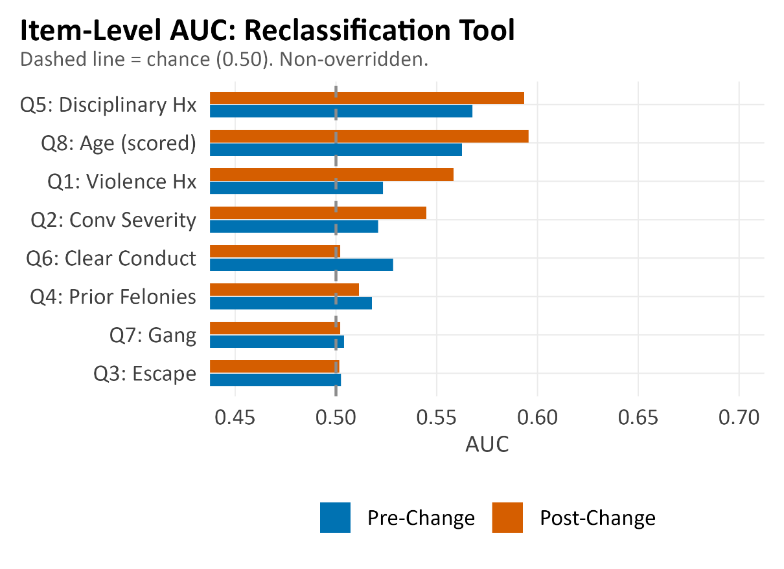
We note that most non-age, non-disciplinary items on both tools hover near chance (AUC ≈ 0.50), which does not necessarily mean those items are useless. Several of them (e.g., escape history, gang affiliation) have low base rates (i.e., they have high rates of 0s on the tool, indicating rarity) that make AUC a weak measure of their operational value. What the item-level visualizations do make clear, however, is that the bulk of the predictive signal in both tools is carried by a very small number of items, primarily age on the initial tool and disciplinary history and age together on the reclassification tool, and that the remaining items contribute relatively little to how well either tool separates future misconduct from non-misconduct on their own.

Random Forest Variable Importance
Figure 8 reports post-revision random forest variable importance scores (mean decrease in accuracy) separately for the two tools. Random forests complement the AUC and logistic regression analyses because they capture non-linear interactions that a linear model cannot, ranking items by how much predictive accuracy is lost when each is randomly permuted. The picture differs substantially across tools. On the initial tool, age is the dominant predictor by an extremely wide margin; every other scored item contributes little or nothing, with several (conviction severity, escape history) showing essentially zero or slightly negative importance. On the reclassification tool, the signal is far more distributed: disciplinary history (Q5) leads, followed closely by age (Q8) and institutional violence history (Q1), but program participation, prior felonies, and conviction severity also contribute meaningfully, and even the lowest-ranked items show modest positive importance. Notably, several reclassification items that hovered near chance on the single-item AUC analysis (e.g., prior felonies, conviction severity) show meaningful importance in the random forest, indicating that their value on the reclassification tool operates through interactions that item-level AUC cannot capture.
Taken together, the item-level AUC and random forest analyses indicate that only a subset of classification factors independently predict misconduct in the non-overridden sample, but the absence of bivariate or multivariate signal for certain items does not necessarily mean they are irrelevant to the classification decision. Three mechanisms explain the pattern. First, several items have extreme base-rate distributions that preclude meaningful statistical differentiation: 98% of individuals score zero on escape history (Q3) on both tools, 75% score zero on institutional violence history (Q1) on the initial tool, and 97% score zero on gang affiliation (Q7) on the reclassification tool. When virtually everyone receives the same score, the factor cannot meaningfully discriminate between those who will and will not commit misconduct, regardless of whether the underlying construct is theoretically related. Second, age confounding suppresses the apparent predictive value of criminal-history items on the initial tool: prior felony convictions (Q4) and prior conviction severity (Q5) are positively correlated with age (Spearman r = +0.31 and +0.21), but age is simultaneously the strongest protective factor against misconduct (r = -0.29), producing an inverted bivariate association in which individuals with prior felonies show 11.5 percentage points lower misconduct than those without (36.4% vs. 47.9%). The inversion disappears once age is controlled for in regression models, but neither Q4 nor Q5 adds significant predictive value beyond age alone (likelihood ratio tests, all p > .40). Third, the tools are not narrowly tailored to optimize predictive accuracy on the outcome measured here. NMCD retains certain lower-predictive-value factors for policy and risk-management reasons that extend beyond statistical prediction of general misconduct: escape history is retained despite its 2% prevalence because the consequences of a successful escape are qualitatively different from, and potentially more severe than, institutional misconduct; gang affiliation carries security implications (e.g., housing restrictions, separation orders) that a binary misconduct outcome does not capture. An item can be statistically non-predictive of general misconduct and still be operationally important for managing specific, low-frequency, high-consequence risks, though whether such considerations are best integrated into a risk-assessment tool or encoded in separate policy is a different question.

Figure 8. Random Forest Variable Importance
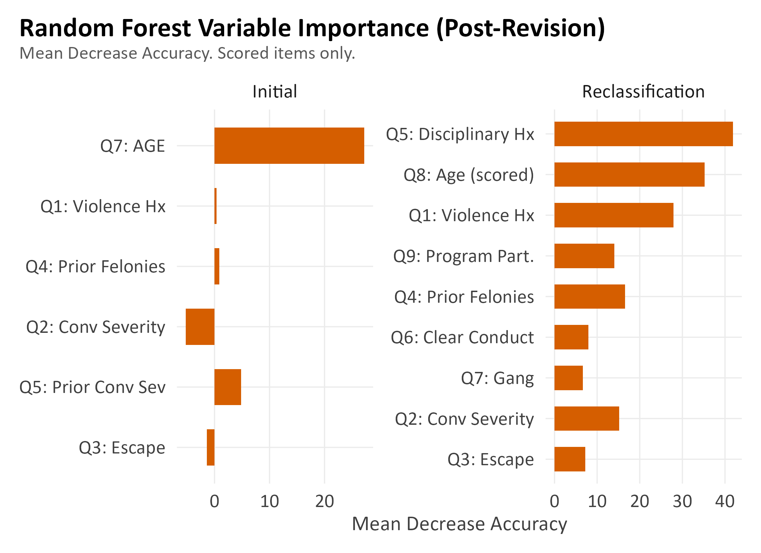
Given age's prominence in both the item-level AUC and random-forest analyses, and the fact that the June 2024 revision specifically expanded the age factor's scoring range, the underlying age–misconduct relationship itself also warrants a closer look. Figure 9 shows 183-day misconduct rates by age category, separately for the initial and reclassification tools and for the pre- and post-revision periods. Per Figure 9, we see that age gradient is steep and stable across periods: the youngest band (under 22) has misconduct rates roughly two to three times higher than the 45+ band on both tools, and this ratio is essentially unchanged from pre- to post-revision, meaning the revised scoring did not distort the underlying age–misconduct relationship that the tools rely on. The gradient is somewhat steeper on the initial tool than on the reclassification tool, which is consistent with the multivariate finding that age is the primary predictor on the initial tool, whereas the reclassification tool has additional behavioral items competing for predictive weight. Within each period, the pre-to-post rates within each age band are modestly lower in the post-period (i.e., roughly a 3–7 percentage point reduction in most cells on both tools), which is consistent with the synthesis finding that the overall post-period misconduct rate reduction is compositional (i.e., the same age group, classified under the new scoring regime, has a slightly lower observed rate) rather than the scoring revision fixing high-risk age groups. Finally, the steepness of the gradient and its stability across periods together justify the June 2024 decision to expand the age factor’s scoring range: age carries a real, reproducible predictive signal that the old maximum of 2 points was underweighting in relation to other factors.
Figure 9. Misconduct Rate By Age Category and Period
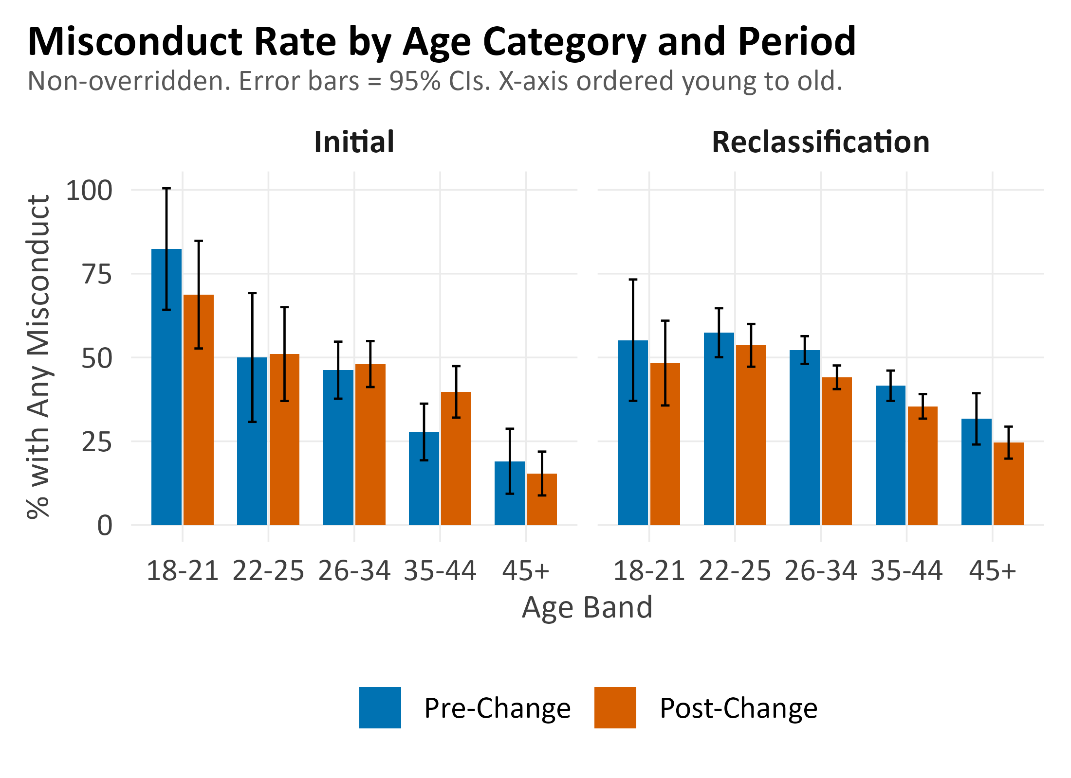
Note. Initial tool (left), Reclassification tool (right). Error bars show 95% Wilson CIs. The X-axis is ordered from young to old.

Override Analysis
Overrides are the mechanism by which a scored custody-level recommendation is changed to a different final placement, either through a policy-driven rule (mandatory overrides) or through the classifying officer's professional judgment (discretionary overrides). Some override activity within a prison system is expected and appropriate, since no instrument fully captures every consideration that bears on placement, and idiosyncratic case-specific factors may reasonably militate against the score-based recommendation. Standards developed by the National Institute of Corrections recommend that discretionary overrides fall in the range of approximately 5% to 15% of all classifications, with total override rates generally not exceeding 15%, and with rates above roughly 20% taken as a signal that the instrument itself may need revision rather than continued adjustment at the case level (Austin, 1998). When override rates substantially exceed these benchmarks, the score-based recommendation functions less as a decision and more as a starting point, and the patterns of who is overridden and in which direction become the more informative quantity. The analyses below examine both the prevalence and the structure of overrides across periods, with explicit reference to these benchmarks.

Table 12. Override Rates By Period and Assessment Type
Period | Tool Type | N | Total Rate (%) | Mandatory Rate (%) | Discretionary Rate (%)
Pre-Revision | Initial | 2,197 | 75.1 | 65.0 | 10.9
Pre-Revision | Reclassification | 7,023 | 54.6 | 45.6 | 10.7
Post-revision | Initial | 2,354 | 62.4 | 42.7 | 25.6
Post-revision | Reclassification | 10,611 | 55.5 | 37.4 | 21.7

The tool-by-tool breakdown clarifies where the override activity is concentrated. For initial classifications, the total override rate declined from 75.1% to 62.4% between the pre-revision and post-revision periods: mandatory overrides decreased by 12.3 percentage points, while discretionary overrides increased by 14.7 percentage points. For reclassifications, the total override rate was essentially unchanged (54.6% to 55.5%), with an 8.2-point decrease in mandatory overrides largely offset by an 11.0-point increase in discretionary overrides.
Figure 10. Monthly Override Rate Trends By Type
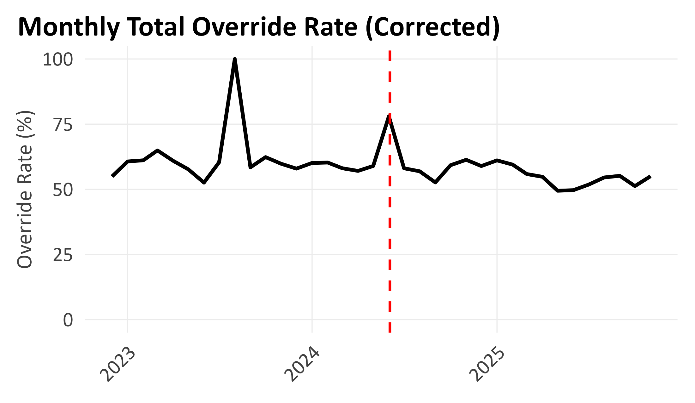

Both tools continue to operate at override rates that substantially exceed the NIC benchmarks, which recommend discretionary overrides in the 5–15% range. The initial tool exceeds the 15% ceiling by more than fourfold; the reclassification tool exceeds it by more than threefold. With override rates at these levels, the practical validity of the classification system depends substantially on whether overrides improve or degrade classification accuracy. At Level II and Level III, overridden individuals (primarily upward overrides) had lower misconduct rates than non-overridden individuals at the same final level, raising the question of whether these upward overrides are consistently necessary: if overridden individuals do not exhibit elevated misconduct at their destination level, the override may have redistributed bedspace without improving risk separation.
Discretionary downward overrides occur when staff place an individual at a custody level below what the scoring instrument recommends. In the all-events non-overridden cohort used throughout this report, there were 690 such overrides (199 pre-revision, 491 post-revision), with 31 overrides being placed at Level I, 194 at Level II, and 465 at Level III. We present the pattern of misconduct among these individuals in Table 13.
The largest disparity is at Level I: downward-overridden Level I inmates had a 61.3% any-misconduct rate compared to 28.4% for non-overridden Level I individuals (chi-square p < .001), and a serious-misconduct rate of 45.2% that is more than double the non-overridden Level I rate (≈19%). Serious violent rates at Level I were similar across the two groups (6.5% vs. ≈5.0%). At Levels II and III, downward-overridden individuals had any-misconduct rates statistically indistinguishable from, and slightly lower than, their non-overridden peers at the same final level (p = .255 at Level II, p = .283 at Level III). This suggests that downward overrides into Levels II and III are reasonably calibrated to risk, while downward overrides into Level I are concentrated among individuals whose behavioral risk is meaningfully above the Level I baseline.
Table 13. Misconduct Profile of Discretionarily Downward-Overridden Classifications
Origin → Destination | N | % Any | % Serious | % SV | p (vs. non-ovr at same level)
Level II → Level I | 22 | 54.5 | 36.4 | 0.0 | -
Level III → Level II | 161 | 42.9 | 32.3 | 11.2 | -
Level IV → Level III | 465 | 49.0 | 32.3 | 14.8 | -
All → Level I (combined) | 31 | 61.3 | 45.2 | 6.5 | .0001
All → Level II (combined) | 194 | 41.8 | 31.4 | 11.3 | .255
All → Level III (combined) | 465 | 49.0 | 32.3 | 14.8 | .283
Note. The downward-overridden group and the same-level non-overridden reference group are both drawn from the all-events non-overridden cohort, pooled across periods; chi-square p-values in the "combined" rows compare these two groups on the share with any guilty misconduct finding within the 183-day follow-up window. Of the 690 discretionary downward overrides, the majority had a documented reason, with the five most common in order of frequency being "Inmate does not require Level IV supervision," "Good institutional conduct," "Prior record not as severe as scale would indicate," "Within six months projected remaining to serve," and "Nature of offense not as severe as scale would indicate."
In our 2024 validation study and subsequent snapshot report, we raised the point that the NMCD faces complex, competing interests in how it classifies inmates, balancing predictive accuracy against organizational constraints, including facility capacity, available services, staffing, and programming. Tolerance for different classification errors is inherently subjective and varies with an organization's risk posture. We recommended that NMCD reduce the use of mandatory medical, mental health, and felony detainer overrides to acceptable levels, noting that high override rates limited the true capacity to evaluate the reliability of the validated classification tool and that inmates overridden into higher custody levels actually tended to exhibit lower misconduct counts than those who scored at the level they were overridden to suggesting that overrides were functioning as a workaround for service-availability gaps rather than as a risk-based decision.
In the period between our 2024 validation study and the present validation, NMCD reduced the use of mandatory medical and mental health overrides. However, it is unclear whether the underlying service availability at Level I facilities was expanded in parallel. In other words, overrides were removed, but we cannot evaluate from the data whether the infrastructure that originally motivated them (i.e., availability of medical care, mental health programming, and appropriate housing) at lower custody levels was provided. This matters because the recommendation for reducing the use of overrides for medical and mental health reasons in Study 1 was explicitly conditional: we advised reducing overrides where practicable, ideally by transferring inmates across facilities within the same custody level to access needed services, or by imposing necessary restrictions within levels, rather than simply discontinuing the override without addressing the underlying service gap at lower level facilities.
Our analysis suggests that a higher proportion of Level I inmates have been engaged in misconduct in the post-revision period than in the pre-revision period (i.e., 29.2% any-misconduct post-revision, up from 19.8% pre-revision in the non-overridden Level I cohort). The post-revision Level I population also differs compositionally from the pre-revision group, most notably in a higher share of individuals with documented mental-health designations and a higher share of younger individuals, both characteristics that carry elevated misconduct risk, and one of which the pre-revision mandatory override policy would have routed to higher custody levels. Whether the elevated misconduct rate reflects the instrument now assigning individuals to their risk-based level or a mismatch between the post-revision Level I population and how Level I facilities are operated is not something we can evaluate with the available data. What the pattern underscores is that a classification tool’s predictive validity at a given level is conditional on how that level is applied, and that override reductions should be paired with monitoring of Level I misconduct and population composition in subsequent validation cycles.
We directly tested whether the medical-mental-health override was picking up behavioral risk beyond what the scored items captured, and whether the same risk signal now appears at Level I following the post-revision relaxation of those overrides. The test compares four groups of Level-I-scored inmates who would have been handled differently under the pre- and post-revision override policies. Group A (pre-revision, Level-I-scored, upward-overridden with a medical/mental-health mandatory reason as the only documented restriction, i.e., not bundled with a detainer, long-sentence, or sex-offense flag) contained 658 individuals. This is precisely the population that the overall research question targets: people who scored as low risk on the instrument, had the mental-health flag, and ended up at Level II solely because of the flag. Across the entire 18-month pre-revision window, 1,177 classification records from 869 unique individuals fit that description exactly, and 90.5% of them (1,061 records) were placed at Level II, 9.3% at Level III (driven either by Q1+Q2+Q3 sub-total escalation or by a discretionary upward bump layered on top of the mandatory rule), and 0.2% at Level IV.
Group A used in the formal statistical test below is a cohort-restricted slice of those 869 individuals: it takes the first classification per person in each period with a full 183-day follow-up window and applies reclassification censoring, which is how the 869 becomes 658. We use this strict MH-only Group A rather than a looser definition (any MH reason present, other reasons permitted, N = 1,354) because the stricter filter rules out the possibility that the A vs. B contrast is driven by co-occurring non-MH reasons; the loose definition gives numerically near-identical results (30.7% vs. 30.5% any misconduct, within 0.2 percentage points), so the finding is robust to the choice. Group B (pre-revision, Level-I-scored, not overridden, stayed at Level I) contained 181 individuals. Group C (post-revision, Level-I-scored, had a documented mental-health acuity code ≥ 1, not overridden, stayed at Level I) contained 252 individuals. Group D (post-revision, Level-I-scored, no mental-health designation, not overridden) contained 324 individuals and serves as the post-revision non-MH reference. All four groups were restricted to the first classification per person in each period with a full 183-day follow-up window, reclassification-censored in the same way as the rest of this report.
Table 14. Misconduct Rates By Group: Pre/post Medical and Mental Health Override Comparison (First Classification Per Person Per Period, 183-Day Follow-Up, Non-Overridden Except As Noted)
Group | Period / Description | N | % Any | % Serious | % SV
A | Pre-revision, Level-I-scored, MH-only upward override | 658 | 30.5 | 21.4 | 9.9
B | Pre-revision, Level-I-scored, not overridden (stayed L-I) | 181 | 21.0 | 12.7 | 4.4
C | Post-revision, Level-I-scored, MH flag, not overridden (L-I) | 252 | 36.5 | 24.6 | 9.1
D | Post-revision, Level-I-scored, no MH, not overridden (ref.) | 324 | 24.7 | 16.4 | 4.3
Note: Group A restricted to pre-revision Level-I-scored inmates, upward-overridden with medical/mental-health as the only documented mandatory reason. Group B is the pre-revision non-overridden Level-I reference. Groups C and D are post-revision non-overridden Level-I inmates with and without a documented mental-health designation, respectively. A vs. B (chi-square p = .012); C vs. D (chi-square p = .002); C vs. A (adjusted OR = 0.99, p = .96).
The unadjusted 6-month any-misconduct rates were 30.5% for strict Group A, 21.0% for Group B, 36.5% for Group C, and 24.7% for Group D. Serious (Class A) misconduct followed the same pattern (A = 21.4%, B = 12.7%, C = 24.6%, D = 16.4%), as did serious violent misconduct (A = 9.9%, B = 4.4%, C = 9.1%, D = 4.3%).
Three contrasts are informative. The first compares Group A with Group B. In the pre-revision period, inmates who were upward-overridden with a medical or mental-health reason as the only documented restriction showed higher observed misconduct than inmates who scored into Level I and were not overridden (30.5% vs. 21.0%, χ²(1) p = .012; adjusted for age, sex, and total score, OR = 1.53 [1.02, 2.31], p = .042). The medical/MH override therefore appears not to have been purely administrative. It was associated with a population whose observed misconduct risk was meaningfully elevated (approximately 50% higher odds of any misconduct) beyond what the scored items captured on their own. The same contrast applied to serious misconduct yields 21.4% for Group A vs. 12.7% for Group B, and applied to serious violent misconduct yields 9.9% vs. 4.4%. The proportional gaps are larger for the more severe outcomes than for any misconduct, suggesting the override was associated not only with a higher frequency of events but also with a higher share of events in the more severe categories.
The second contrast compares Group C with Group D. In the post-revision period, mental-health-flagged individuals at Level I showed higher observed misconduct than non-MH Level I individuals (36.5% vs. 24.7%, χ²(1) p = .002; adjusted OR = 1.64 [1.13, 2.39], p = .010). The gap at Level I post-revision is of essentially the same magnitude (roughly 60% higher odds of any misconduct) as the gap the override was flagging pre-revision. The third contrast compares Group C with Group A. The post-revision MH Level I group has misconduct rates statistically indistinguishable from the pre-revision MH-only upward-overridden group (36.5% vs. 30.5%; adjusted OR = 0.99 [0.69, 1.42], p = .96). The adjusted odds ratio is essentially exactly one, indicating that the same risk profile is now housed at a less restrictive custody level than it was previously, with no detectable change in behavior.
Taken together, the three contrasts suggest that the pre-revision medical/MH overrides were identifying a behavioral risk signal rather than serving as a purely administrative convenience, that the post-revision relaxation of those overrides is associated with the same signal now appearing inside Level I rather than being routed upward, and that the individuals in question have not exhibited a corresponding change in behavior following the lower custody placement. Descriptively, Level I is now absorbing a group with roughly 60% higher odds of misconduct than it previously did, a pattern that is consistent with findings reported earlier in the Level I Misconduct Deep Dive section. Whether the post-revision placement of this higher-risk group at Level I is appropriate, that is, whether the classification correctly routes these individuals to their risk-based level and whether housing, programming, supervision, and service capacity at Level I are well-matched to the population now arriving there, is a question the present data cannot evaluate and is best addressed by pairing future validation cycles with facility-level operational data. Continued monitoring of Level I misconduct and mental-health acuity distribution should be a priority in subsequent validation cycles.
Two follow-up analyses add texture to these findings. First, a bundling analysis of the 1,354 pre-revision Level-I-scored classifications overridden with a medical/MH reason shows that misconduct rates were essentially flat across the number of co-occurring mandatory reasons (30.6% any-misconduct with MH alone, 36.2% when bundled with three or more additional reasons), indicating that the identity of the co-occurring flag matters more than the count; the standalone MH-only group had the highest serious violent rate in the table (10.1%), reinforcing that the MH flag was capturing elevated serious-violence risk beyond what the scored items registered. Second, a within-person comparison of 266 individuals who appeared in both periods, overridden upward pre-revision for medical/MH reasons and left at Level I post-revision, shows no deterioration in behavior following the policy change. Any-misconduct was identical across periods (30.8% pre, 30.8% post; McNemar's exact p = 1.00), and serious and serious violent misconduct trended upward (17.3% to 24.1% and 5.3% to 6.4%, respectively) but did not reach significance (Wilcoxon signed-rank on event counts, p = .35). Stratifying by pre-period override frequency, individuals with two or more prior MH overrides showed a 10-point within-person decrease in any-misconduct (41.8% to 31.8%), and those with three or more showed a 20-point decrease (61.5% to 41.0%). These patterns are consistent with regression to the mean and with selection into the post-revision Level I cohort being conditional on relative behavioral stability.
In sum, the overall finding of this subsection may at first appear to conflict with our 2024 validation study, which examined medical/mental-health upward overrides against both the origin (Level I) and destination (Level II) reference groups and concluded that the misconduct profile of MH-overridden inmates resembled the Level I baseline more closely than the Level II baseline. The current analysis, by contrast, finds that MH-overridden inmates (Group A) show misconduct rates meaningfully higher than non-overridden Level I inmates (Group B). The two findings are less contradictory than they may appear. Both studies place the MH-overridden group at an intermediate point on the misconduct distribution, above the natural Level I baseline and below the natural Level II baseline; they differ primarily in where along that intermediate range the point estimates land and in how the difference from Level I is framed. A likely contributor to the directional shift is that the 2024 MH-overridden group was observed while at Level II (its actual placement under the pre-policy regime), where more intensive mental-health services, housing options, and supervision were presumably available, whereas the current analysis includes cases drawn from the same pre-policy regime but evaluated alongside the post-revision context in which many comparable individuals are now housed at Level I without a clear indication that equivalent services have followed them. In other words, the 2024 observation that MH-overridden individuals "looked like" Level I behaviorally may in part have reflected the suppressive effect of appropriate service provision at Level II rather than a low underlying propensity for misconduct.
Two additional, non-mutually-exclusive factors may also account for residual differences between the two reports. First, the current analysis isolates the MH-only subgroup far more strictly than the 2024 study did. Group A here is restricted to pre-revision Level-I-scored classifications in which medical/MH was the only documented mandatory reason, whereas the 2024 study treated MH-overridden cases as a single bundled category that included classifications with medical/MH flagged alongside one or more additional restrictions (e.g., detainer, long-sentence, sex-offense). Those co-occurring flags carry their own behavioral risk signatures, and the current bundling analysis (Table X) shows that when medical/MH was paired with certain flags (notably sex-offense), misconduct rates were actually among the lowest in the table, while with others (second-degree murder, violence to a child) they were among the highest. Lumping all of these together, as the 2024 operationalization did, tends to pull the aggregate MH-overridden estimate toward the mix of co-occurring reasons rather than isolating the MH signal itself. Second, the analytical windows differ substantially in both length and centering. The 2024 validation drew on approximately six years of classification data (2017 through 2023), spanning multiple policy regimes and facility-level operational changes, whereas the present analysis restricts to an 18-month symmetric window centered on the June 2024 revision in order to isolate the effect of the policy change. It is possible that the association evolved over time between MH/Medical restrictions and the narrower window yields smaller subgroup sample sizes and is more susceptible to point-estimate movement from period-specific composition than the longer 2017–2023 window was; even in the absence of any underlying behavioral change, we would expect some directional drift in the estimates simply from the combination of narrower time coverage, smaller Ns, and the stricter subgroup definition.
Table 15. Pre-Revision Medical and Mental Health Override Bundling Analysis (N = 1,354 Level-I-Scored Classifications With a Medical/mh Mandatory Reason)
Bundling Depth | N | % of MH Overrides | % Any Misconduct | % Serious
MH reason alone | 684 | 50.5% | 30.6% | 21.0%
MH + 1 additional mandatory reason | 434 | 32.1% | 31.6% | 21.2%
MH + 2 additional reasons | 189 | 14.0% | 28.0% | 19.0%
MH + 3 or more additional reasons | 47 | 3.5% | 36.2% | 23.4%
Note: Bundling depth counts how many additional mandatory override reasons co-occurred with the medical/mental-health flag. Misconduct rates are essentially flat across depths, indicating that the number of co-occurring reasons is a poor proxy for underlying behavioral risk; the identity of the co-occurring reason (e.g., long sentence, second-degree murder, child violence) carries more information than the count.

Custody Level and Opportunity Suppression
The residual Level III/IV near-tie noted above raises a substantive question: if Level IV houses the highest-risk individuals, why does its any-misconduct prevalence not visibly exceed Level III's? One candidate explanation is that prevalence (i.e., whether a person had at least one guilty finding) captures only part of the picture. A different view is the average number of misconduct events accumulated per person at each level (i.e., event intensity), which weights repeated misbehavior rather than treating a single guilty finding and ten guilty findings as equivalent. Figure 12 displays the prevalence-versus-intensity comparison that we summarize numerically below, with prevalence in the top row (i.e., any misconduct, serious, and serious violent) and event rate per 100 person-days in the bottom row.
Figure 12. Custody Level Opportunity Suppression Pattern
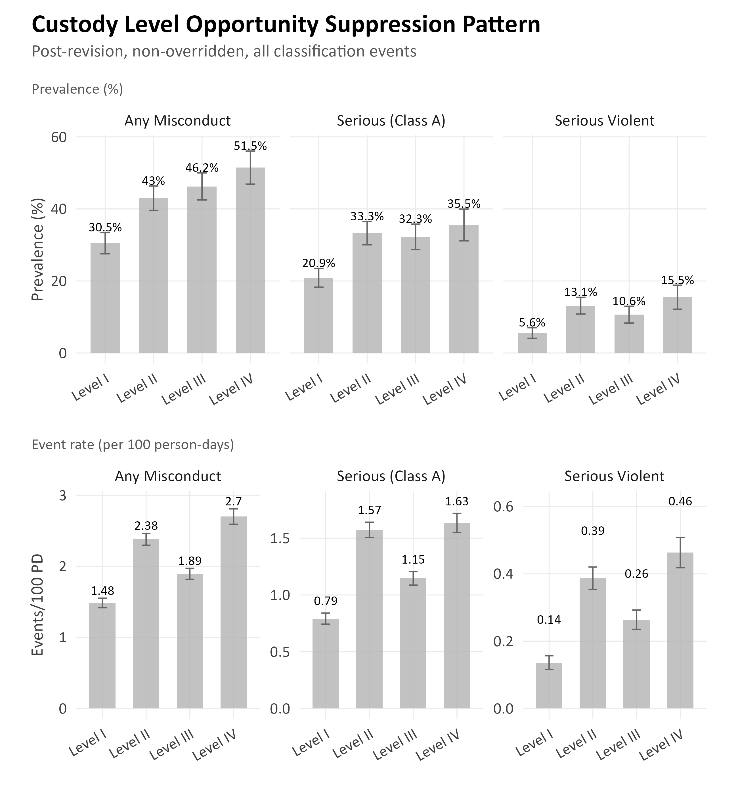
The narrow gap at the top of the prevalence gradient (Level III = 46.2%, Level IV = 51.5%) is a finding the scoring revision materially improved: the pre-revision L3/L4 inversion is now resolved, with Level IV exceeding Level III by roughly five percentage points. The middle of the gradient is less tidy, however, because Level II (43.0%) sits only about three percentage points below Level III, a narrower-than-expected separation between adjacent custody levels.
To understand whether the compression in the middle reflects a ceiling effect at the top of the scale or a calibration issue between adjacent levels, we computed a complementary metric: the rate of guilty misconduct findings per 100 person-days at each level, which weights repeated events rather than treating a single guilty finding and ten guilty findings as equivalent. Figure 14's bottom row displays these event rates for any serious (Class A), and serious violent misconduct. For any misconduct, the post-revision rates are approximately 1.48 per 100 person-days at Level I, 2.38 at Level II, 1.89 at Level III, and 2.70 at Level IV. Level IV exhibits the highest event rate, consistent with its position at the top of the prevalence gradient, but the pattern is not cleanly monotonic across levels: Level II's event rate exceeds Level III's for any misconduct, and the same L2 > L3 reversal holds for serious and serious violent rates. The event-intensity view therefore confirms that the revision has better ordered the L3/L4 boundary than it did pre-revision, while also pointing to the compression issue toward the L2/L3 boundary rather than the top of the scale.
Two caveats apply to the event-rate comparison. First, the underlying exposure window is not identical across individuals. NMCD policy requires immediate reclassification after any guilty finding, and the cohort construction censors follow-up at the next reclassification event; the mean observed exposure is approximately 147 days rather than the nominal 183. The rate denominator mechanically accounts for this (i.e., individuals with shorter windows contribute fewer person-days), but it also means the rates best characterize the early part of the 183-day window, and misconduct patterns that emerge later for initially well-behaved individuals are underrepresented. Second, the rates aggregate across individuals, so a small number of high-frequency offenders (which we discuss in more detail in the Misconduct Concentration section) can pull a level's rate upward without reflecting typical behavior at that level. Neither caveat overturns the figure's qualitative patterns, but both argue against treating the specific rate values as precise estimates of steady-state misconduct intensity at each level.

Understanding the Post-Revision Misconduct Patterns

Our analyses so far indicate that, on balance, misconduct rates were lower in the post-revision period overall, with variation by custody level: rates were higher at Levels I and IV and lower at Levels II and III, relative to pre-revision. This pattern raises a natural question: did the scoring revision itself contribute to these differences, or do they primarily reflect other changes that occurred over the same window? A classification instrument is a measurement tool that assigns custody levels rather than something that directly shapes behavior; if the revision did contribute to observed misconduct patterns, the pathway would necessarily be indirect, with revised scores leading to different custody-level assignments, which in turn place individuals in different housing and supervision environments, which in turn shape opportunities for and likelihood of detection of misconduct. The analyses that follow characterize the post-revision association from several complementary angles (e.g., adjusted regression, decomposition, regression discontinuity, interrupted time series, within-person comparison) and test whether the association is accounted for by measured compositional differences across periods. None of these approaches, individually or jointly, establish a causal effect of the revision, because doing so would require that all relevant confounders are measured and balanced across periods, an assumption the available data cannot verify. What they can do is narrow the set of explanations consistent with the observed patterns and surface where the evidence converges and where it does not.

Adjusted Logistic Regression
One way to characterize the post-revision period's association with misconduct, while accounting for observable differences in who is being classified, is a sequentially adjusted logistic regression. The idea is straightforward: we fit a predictive model in which the outcome is a binary misconduct indicator and the key predictor is a post-revision indicator (1 = post, 0 = pre). We then add covariates one layer at a time (i.e., demographics, total classification score, remaining sentence length, and facility fixed effects) and watch how the post-revision coefficient moves. If the coefficient is stable as controls are added, the post-period association is not accounted for by the measured covariates. If the coefficient attenuates (i.e., becomes smaller) substantially toward the null, the apparent period difference is largely explained by compositional differences in the measured covariates across periods rather than by a within-group rate difference. This framing describes statistical associations and how they shift with adjustment, not causal effects; any causal interpretation of a period association would additionally require that no unmeasured confounders differ across periods, which the adjusted logistic regression alone cannot establish. Table 16 reports the estimated period odds ratio (with 95% CI and p-value) for each of the three misconduct outcomes, comparing the unadjusted estimate to the fully adjusted estimate that includes facility fixed effects.
Table 16. Odds Ratios For Post-Revision Period, Non-Overridden Classifications
Outcome | Model | OR [95% CI] | p-value
Any Misconduct | Unadjusted | 0.785 [0.704, 0.874] | < .001
Any Misconduct | Adjusted (w/ facility FE) | 0.748 [0.669, 0.837] | < .001
Serious Misconduct | Unadjusted | 0.810 [0.727, 0.903] | < .001
Serious Misconduct | Adjusted (w/ facility FE) | 0.865 [0.779, 0.961] | .007
Serious Violent | Unadjusted | 0.753 [0.674, 0.842] | < .001
Serious Violent | Adjusted (w/ facility FE) | 0.759 [0.649, 0.889] | < .001

Figure 13. Forest Plot of Period Effect On 183-Day Misconduct
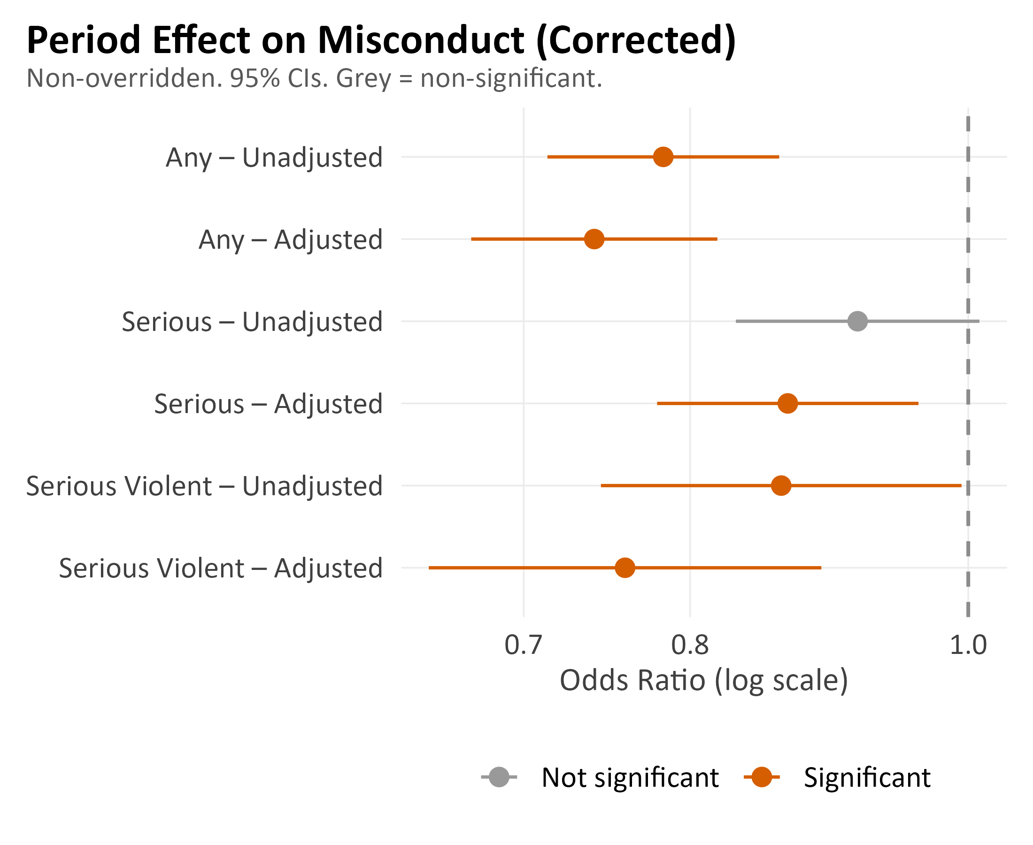
The unadjusted model indicates that the odds of any misconduct are roughly 22% lower in the post-revision period than in the pre-revision period (OR = 0.785 [0.704, 0.874], p < .001). Adding demographic controls, total classification score, standardized remaining sentence length, and facility fixed effects reduces this estimate only modestly: in the fully adjusted model with cluster-robust standard errors, post-revision any-misconduct odds are approximately 25% lower than pre-revision (OR = 0.748 [0.669, 0.837], p < .001). The same directional association holds across the three outcome definitions. Post-revision any-misconduct odds are about 25% lower (OR = 0.748 [0.669, 0.837], p < .001), serious-misconduct odds about 14% lower (OR = 0.862 [0.764, 0.972], p = .016), and serious-violent misconduct odds about 26% lower (OR = 0.739 [0.616, 0.887], p = .001), all after full adjustment. The monthly guilty finding rate is not a statistically significant predictor in the pooled model (OR = 0.78, p = .314), suggesting that changes in detection intensity do not account for the observed differences. Because adjustment produces only modest attenuation rather than moving the estimates toward the null, compositional differences in the measured covariates account for some but not the majority of the unadjusted pre-post difference; the remainder is consistent with the post-revision period differing from the pre-revision period in ways that these covariates do not capture, which could include unmeasured compositional differences, environmental changes, or a combination. Adjusted logistic regression cannot distinguish among these possibilities on its own, which is why the subsequent sections triangulate with regression discontinuity, interrupted time series, and within-person comparisons.

Facility-Level Fixed Effects
Misconduct rates vary substantially across NMCD facilities for reasons that have nothing to do with the classification instrument: differences in custody environment, staffing ratios, available programming, proximity to reentry resources, and local institutional culture all could produce facility-to-facility variation in the probability that a given individual will receive a guilty misconduct finding in a fixed follow-up window. If the mix of individuals classified to each facility changed between the pre- and post-revision periods, part of what looks like a period difference in misconduct could instead be a between-facility composition difference dressed up as a period effect. To account for this, we include facility fixed effects (i.e., dummy indicators for each of the named facilities with adequate sample size) alongside the individual-level covariates in all subsequent models.
The facility fixed effects are jointly significant (χ² = 31.90, df = 14, p = .004), indicating that facilities differ meaningfully from one another in misconduct rates after accounting for who is housed there. Adding these indicators to the model that already controls for demographics and total score shifts the post-revision period odds ratio from 0.85 to 0.66, a non-trivial movement that confirms facility composition is doing measurable work in the pre-post comparison. Several individual facilities stand out: NENMDF (OR = 0.41 [0.22, 0.77]) and SWF (OR = 0.37 [0.20, 0.70]) show significantly lower misconduct than the reference facility, while WWCF shows a directionally higher rate that does not reach conventional statistical significance (OR = 1.32 [0.66, 2.62], n.s.). These are statistical associations within our adjusted model, not claims about facility operations.
Figure 14 decomposes the aggregate estimate into its facility-specific components, reporting the fully adjusted period odds ratio (with 95% CI) separately for each of the facilities. Facilities whose confidence intervals sit entirely to the left of the null line (OR < 1) had lower post-revision misconduct than pre-revision; those to the right (OR > 1) had higher; those whose intervals cross the null are indistinguishable from no change. The heterogeneity visible across facilities is what produces the joint significance of the facility fixed effects in the pooled model and is the reason we treat facility as a first-order covariate throughout the remaining analyses. Read together, the two figures make a single point: the aggregate post-revision association with misconduct is partly driven by how the classification shift redistributed individuals across facilities rather than being uniformly present within each facility, and the adjusted estimate reported in Table 12 should be read as an average over that facility-level variation.

Figure 14. Facility-Level Odds Ratios For Period Effect
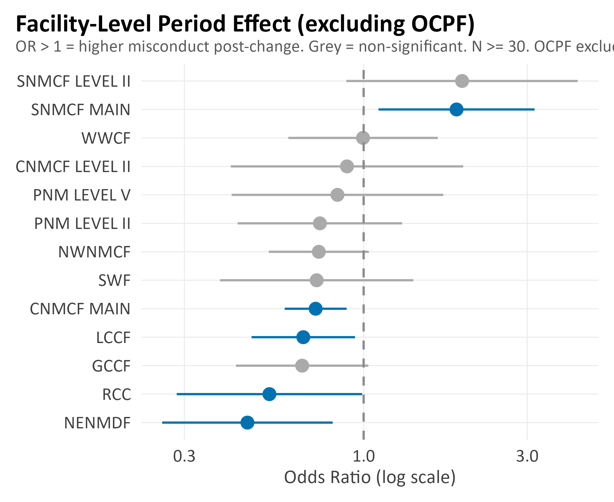
Note. Non-overridden classifications. OR > 1 = higher misconduct post-revision. Facilities with N < 30 excluded.

Survival Analysis: Time to First Misconduct
The logistic regression above treats misconduct as a yes/no outcome within a fixed 183-day window. That framing loses information: two people who both eventually get a guilty finding are counted identically, even if one was found guilty on day 5 following a classification event and the other on day 170. Survival analysis uses the timing information directly. The outcome is a hazard (i.e., the instantaneous probability of an event for someone who has not yet had one), the predictor of interest is again the post-revision indicator, and a hazard ratio (HR) below 1 means events happen more slowly in the post period, while an HR above 1 means they happen faster. Survival analysis also handles the reclassification-censoring problem more naturally than logistic regression, because it treats the censored observation time as known rather than having to exclude those individuals or impute them. We report unadjusted and fully adjusted hazard ratios, controlling for age, gender, race, custody level, and assessment type, with robust standard errors clustered on the individual to handle repeated classifications of the same person, separately for any misconduct and serious violent misconduct.

Table 17. Cox Hazard Ratios For Time to First Misconduct (Post vs. Pre)
Outcome | Model | HR [95% CI] | p-value
Any Misconduct | Unadjusted | 0.852 [0.786, 0.924] | < .001
Any Misconduct | Adjusted | 0.949 [0.875, 1.029] | 0.207
Serious Violent | Unadjusted | 0.88 [0.79, 0.98] | 0.010
Serious Violent | Adjusted | 0.97 [0.87, 1.08] | 0.591

After adjustment for age, gender, race, custody level, and assessment type, the hazard ratio is 0.949 [0.875, 1.029] (robust SEs clustered on individual). This near-null adjusted hazard ratio suggests that, conditional on individual characteristics and classification level, there is no meaningful difference in how quickly misconduct occurs between periods.
Figure 15. Kaplan-Meier Survival Curves By Custody Level and Period
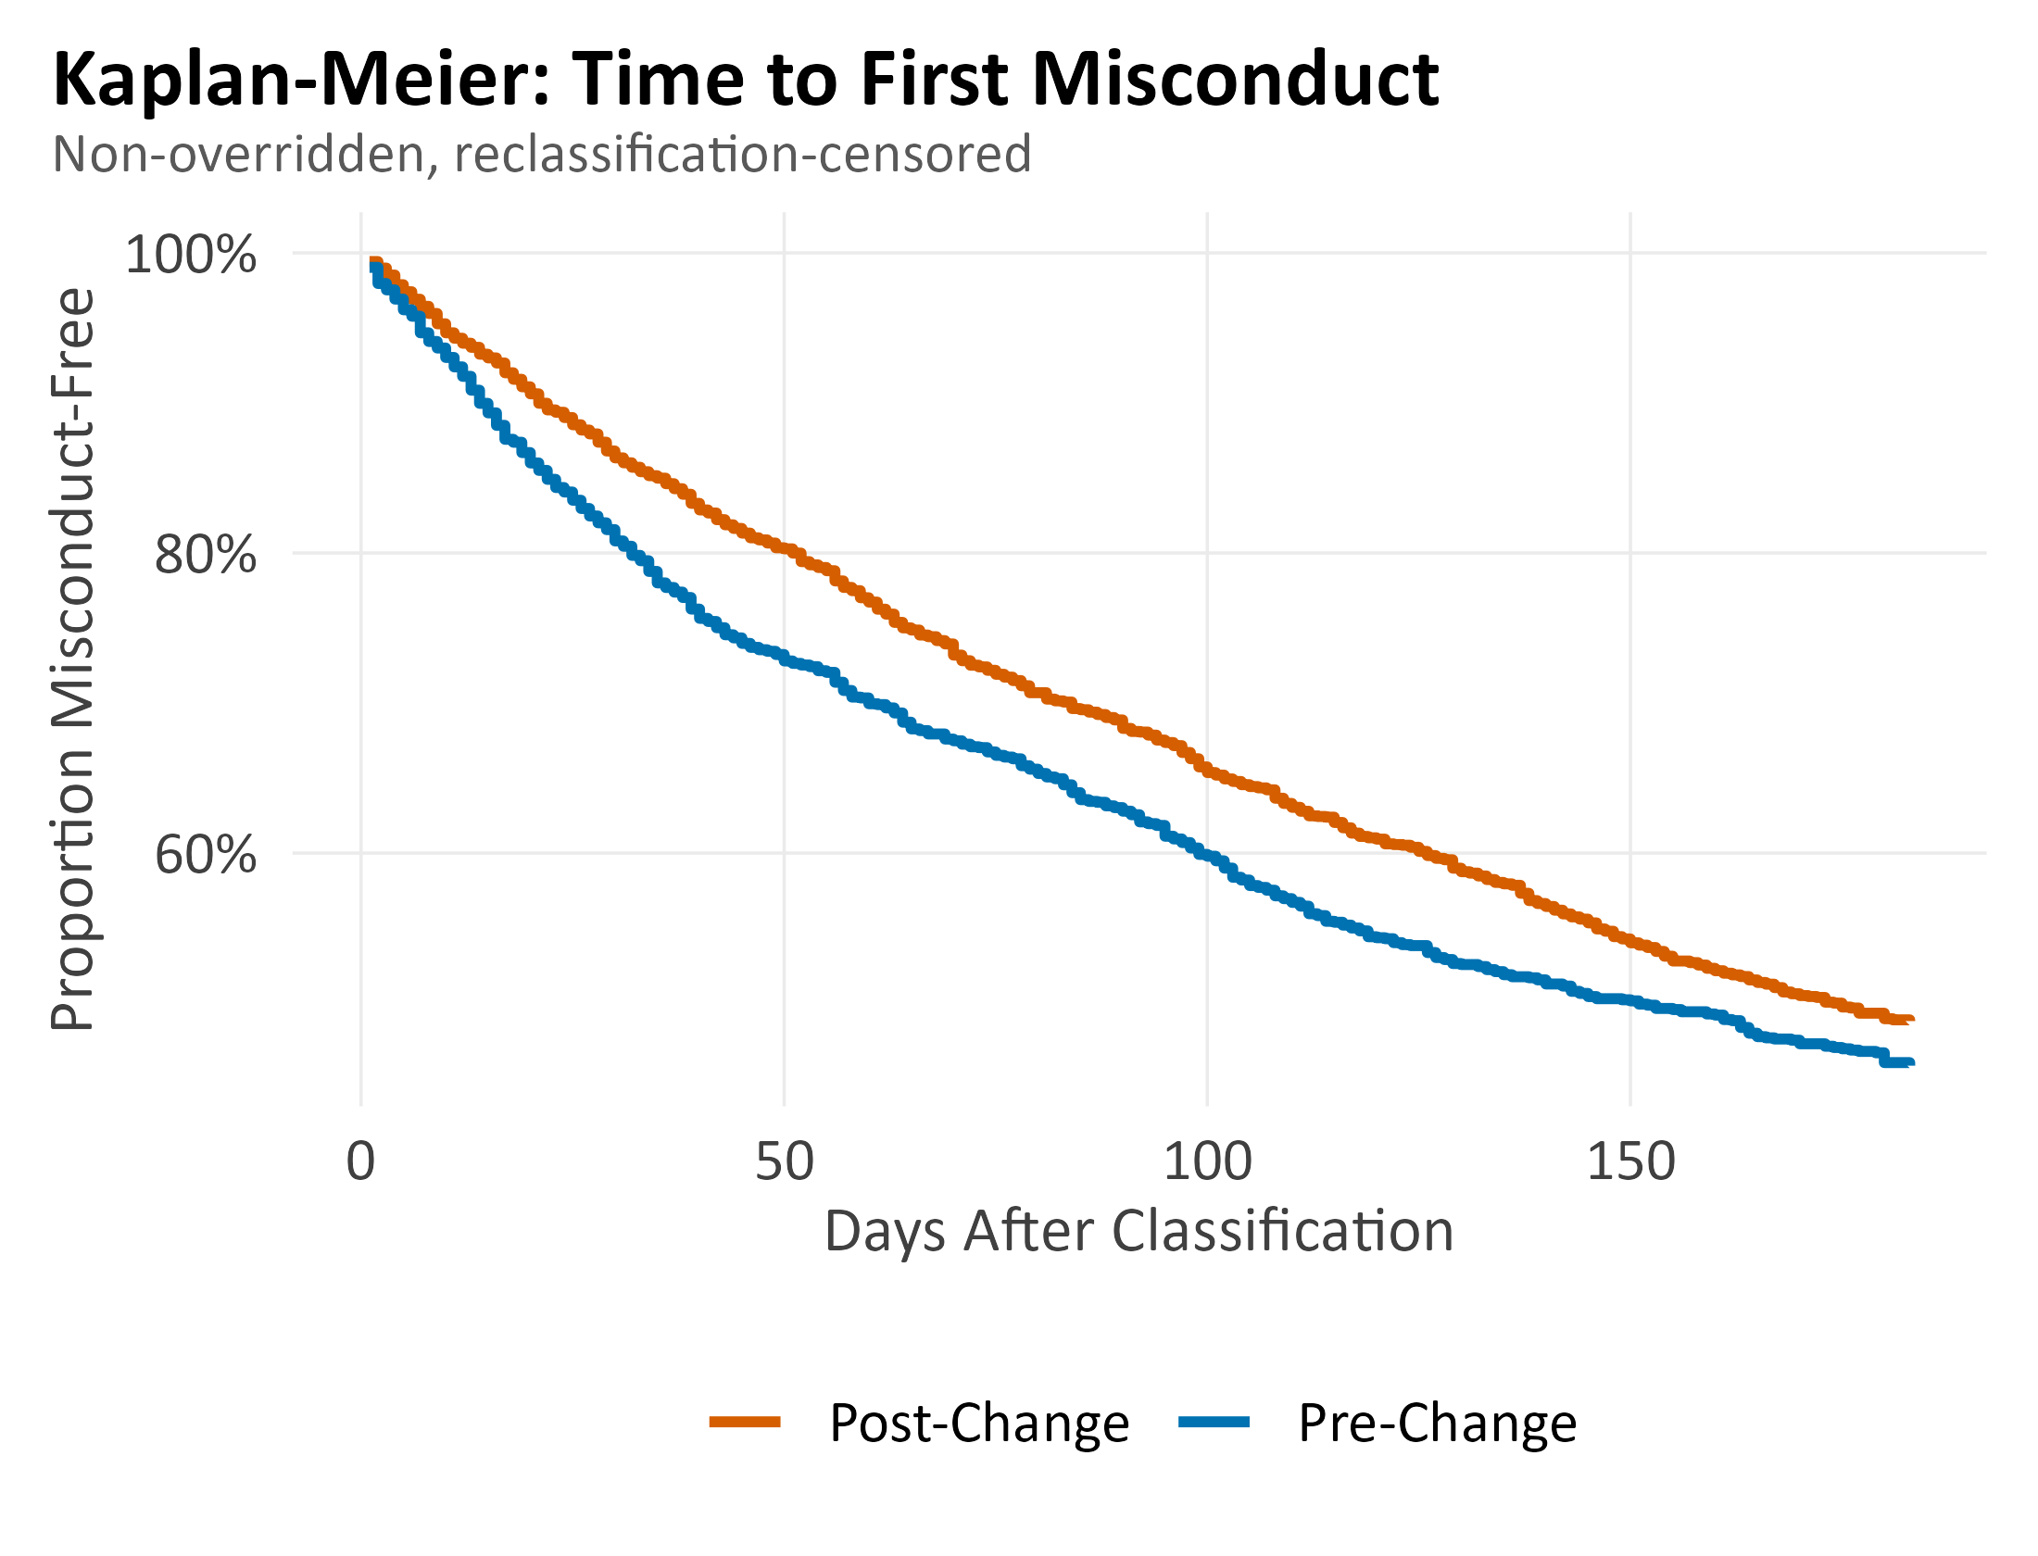

Score-Threshold Regression Discontinuity
A regression discontinuity (RD) design asks a narrower question than the analyses we have reviewed so far, but one that is useful precisely because it is narrow. Consider two individuals whose total classification scores are almost identical, (e.g., 8 and 9 on the revised instrument), but who fall on opposite sides of the Level I / Level II cutoff. On the measured items, these two individuals look essentially alike; what differs is the custody level they are assigned to, and with it the facility they are housed in, the degree of supervision they have, and the peers they are exposed to. If those environmental differences, rather than individual characteristics, drive misconduct, we should see a jump in misconduct rates at the score threshold itself. If we see no jump, the threshold-induced change in environment does not appear to be moving outcomes at the margin.
We ran this test at each of the three custody-level cutoffs (Level I/II at score 8/9, Level II/III at score 14/15, and Level III/IV at score 20/21), using local linear regression with a ±3-point bandwidth around each threshold. At all three cutoffs, the estimated discontinuity in misconduct at the threshold was small in magnitude and not statistically distinguishable from zero (all p > 0.25). Figures 19a and 19b show the Level I/II and Level II/III boundaries visually: the fitted lines on either side of each cutoff sit at similar heights, with no discernible jump where the custody level changes. Within this bandwidth, crossing a custody-level threshold does not appear to move misconduct rates up or down.
We want to highlight two limitations of the RD analysis. First, RD is informative near the thresholds and silent elsewhere. The comparison it supports is between individuals who barely missed a higher level and individuals who barely made it; it says nothing about someone scoring 25 (well inside Level IV) versus someone scoring 15 (at the Level II/III boundary), and any accumulated environmental differences between those two would not be visible in the local estimates. Second, a null RD result is a statement about margins, not about the average effect of custody-level placement across the full score distribution. With those scope conditions in place, the RD results suggest that whatever the revised scoring instrument does to misconduct patterns, it is not operating principally through sharp environmental discontinuities at the custody-level cutoffs themselves. Consistent with this, the revision's most visible operational effect is on how individuals are distributed across facilities and custody levels, rather than on behavior observed within a narrow score window.
Figure 16a. Regression Discontinuity at the Level I / Level II Boundary (score 8/9)
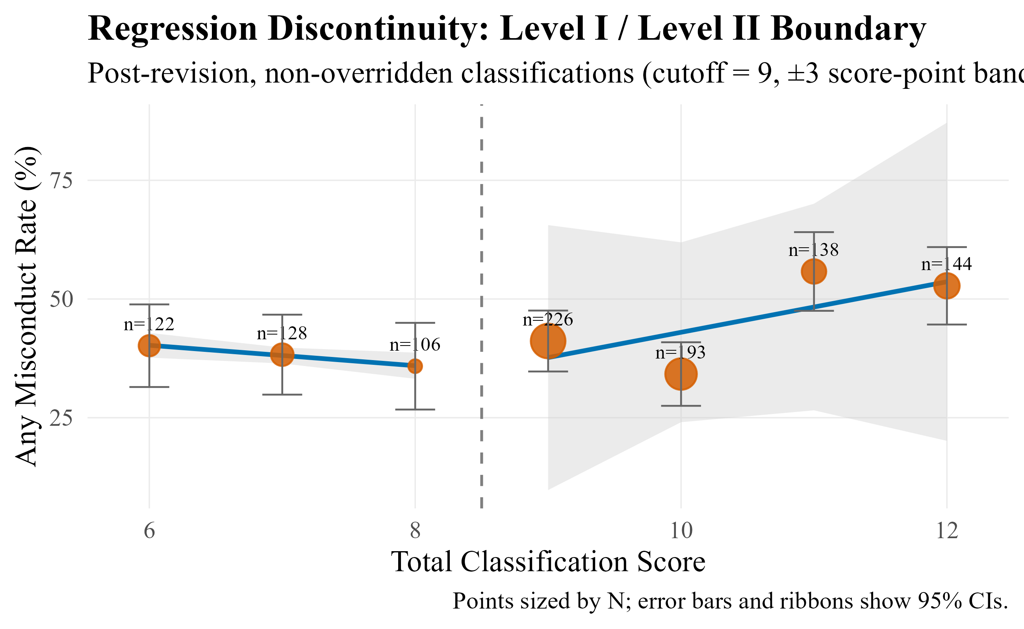

Figure 16b. Regression Discontinuity at the Level II / Level III Boundary (score 14/15)
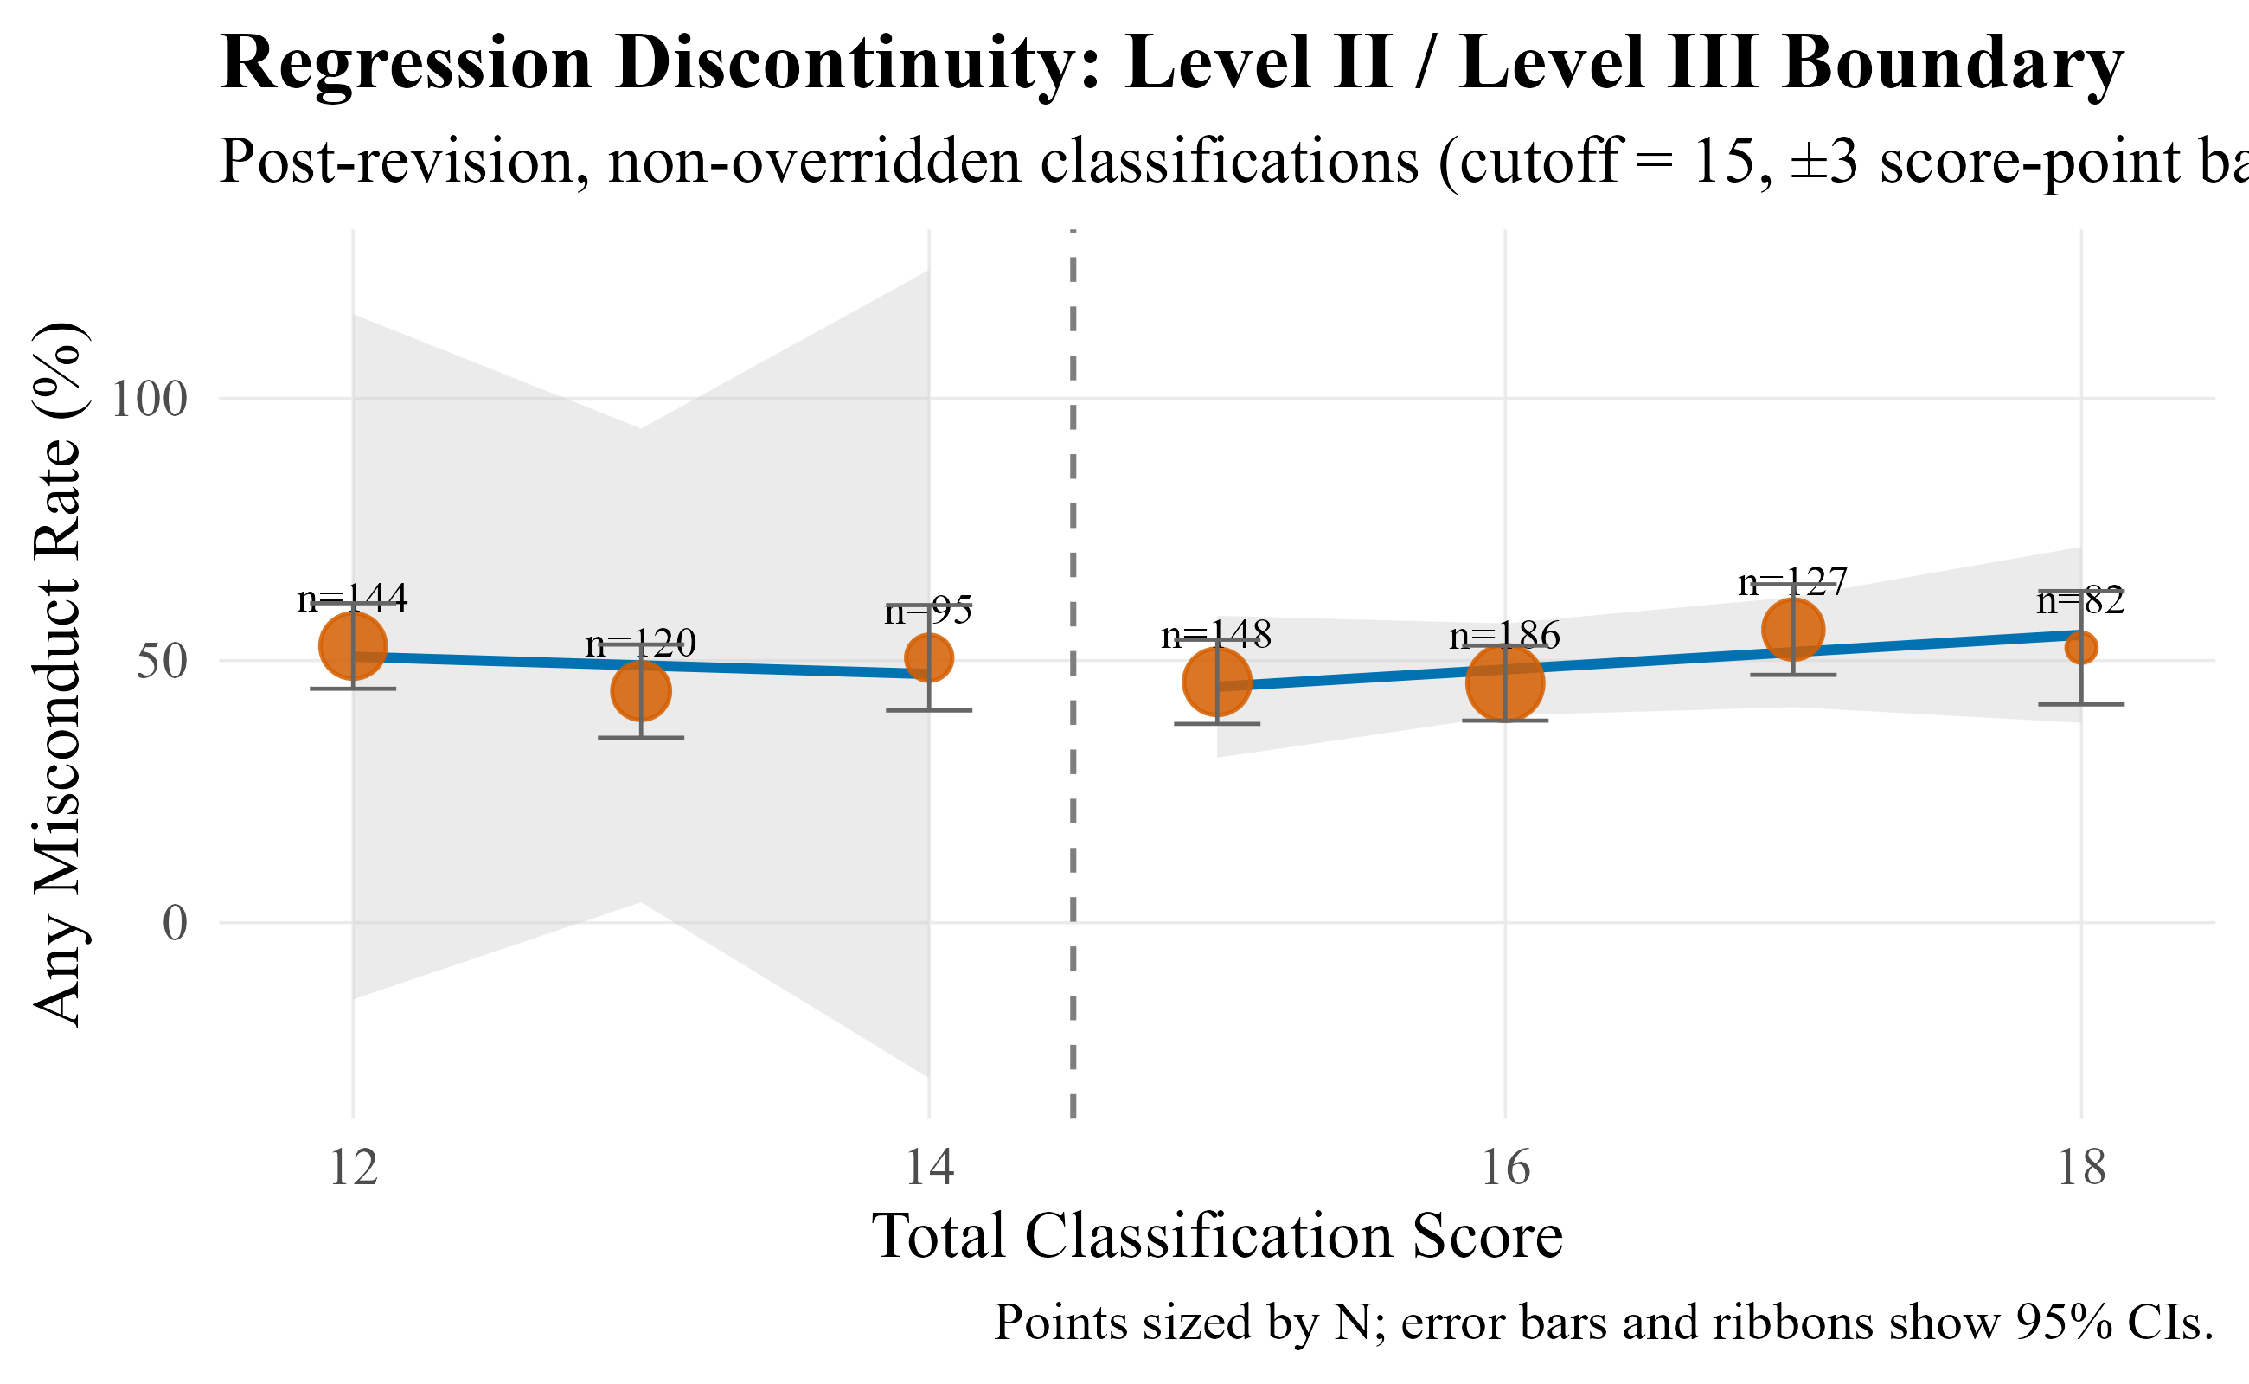

Interrupted Time Series
An interrupted time-series (ITS) analysis asks whether the outcome trajectory changes shape at a known intervention date, over and above the trend that was already in place. The logic is straightforward. For our purposes, the ITS tracks the monthly any-misconduct rate across the study window, fit a single segmented regression that simultaneously estimates the pre-revision slope, the level change at the June 2024 revision date, and the slope change afterward, and compares what actually happened to a projected counterfactual line drawn by extrapolating the pre-revision trend forward. If the revision was associated with a meaningful shift in the trajectory, the fitted line should separate from that counterfactual at the cutoff, in either level, slope, or both. Figure 19 shows the fitted ITS model alongside the counterfactual projection.
The estimated level shift at the June 2024 revision is -5.5 percentage points (p = 0.159), meaning that immediately after the revision date the fitted monthly misconduct rate dropped roughly five and a half points below where the pre-period trend alone would have predicted, though this finding was not statistically significant. The post-revision slope also drifts modestly downward, at -0.34 percentage points per month (p = 0.475), indicating that the gap between the fitted line and the counterfactual widens a bit further over the post-period rather than closing. Neither coefficient reaches conventional statistical significance, which is worth noting directly: with only 18 months of post-revision data, segmented regression is underpowered to detect shifts of this magnitude with high precision. What the ITS contributes is a direction and an approximate size for the association at the revision date (downward, about five percentage points in level, with a mild additional downward drift afterward).

Figure 17. Interrupted Time Series (Monthly Misconduct Rate)
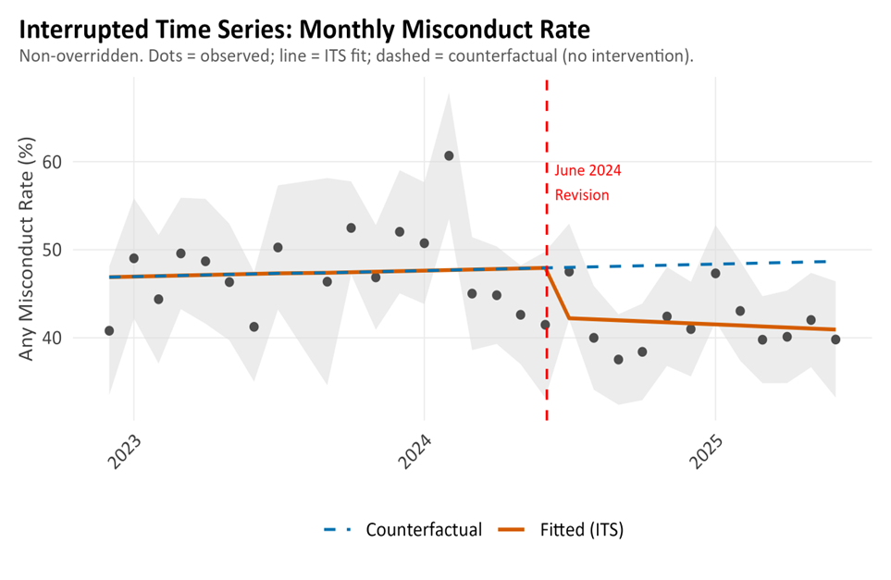
Note. Dashed line marks June 2024 revision. Analysis was conducted at June 2025 to ensure full 183-day follow-up for all cohorts. Shaded band = 95% CI.
To evaluate whether a shift of this size is unusual in this series, we ran the same segmented regression at three placebo dates that do not correspond to any tool change: June 2023, December 2023, and January 2024. If the June 2024 shift simply reflects ordinary month-to-month volatility in the series, we should see comparable shifts when we pretend an intervention happened on other dates. We did not. None of the placebo dates produced a statistically distinguishable level shift (p = 0.785, p = 0.254, p = 0.751, respectively), and the magnitudes were smaller than the shift we observed around the point at which the scoring tools were revised. The June 2024 estimate, while itself not statistically significant, is the largest of the four in magnitude and the only one pointing clearly in the downward direction. This does not elevate the ITS to a causal identification of the revision's effect; what it does is narrow the set of explanations consistent with the observed pattern by making "June 2024 is a statistical artifact indistinguishable from any other month" a less plausible reading. The direction and approximate magnitude of the ITS estimate are broadly consistent with the adjusted logistic regression and within-person analyses reported elsewhere in this section, and we treat the ITS as one more line of corroborating evidence rather than as the primary anchor for any inference about the revision.

Figure 18. ITS Placebo Comparison
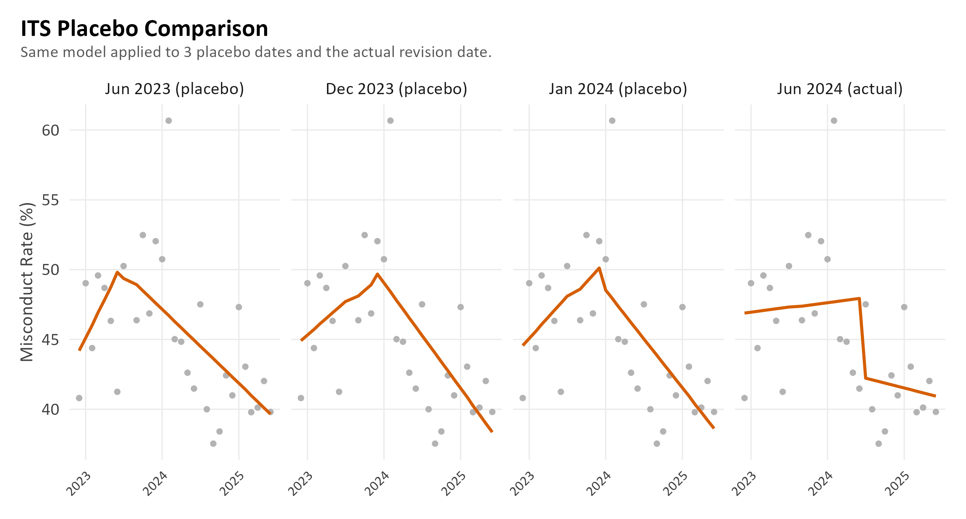

Within-Person Analysis
A within-person comparison examines whether the same individuals, followed over time, show different misconduct patterns before and after the policy change. Because each person is compared to themselves rather than to a different set of people, the comparison is not vulnerable to between-period differences in stable individual characteristics such as criminal history or baseline demographic composition. It is, however, vulnerable to cohort-selection restrictions: to be eligible, an individual must have had a non-overridden classification in each period for which a full 183-day follow-up window could be observed, using the first such classification in each period. Of the 6,594 unique individuals in the 18-month window, 3,023 had at least one classification in both periods, but only 750 satisfied the stricter cohort rules required for a paired pre-post comparison. Because of this, the within-person estimates that follow describe this narrower cohort of individuals who remained in the system across the revision, were not overridden in either of the compared classifications, and had sufficient follow-up time on both sides of the cutoff; patterns among individuals excluded by these filters are not represented.
Among these 750 paired individuals, 25.2% (n = 189) had no misconduct in either period, 26.8% (n = 201) had misconduct only in the pre-revision period, 18.3% (n = 137) had misconduct only in the post-revision period, and 29.7% (n = 223) had misconduct in both periods. The overall misconduct rate for this cohort was 56.5% pre-revision and 48.0% post-revision. McNemar's test of symmetry on the discordant pairs (201 pre-only vs. 137 post-only) yields p = 0.001, meaning that the asymmetry between "misconduct only pre" and "misconduct only post" is larger than chance variation would typically produce. The direction of the asymmetry is a reduction: within this paired cohort, more individuals moved from having misconduct pre-revision to no misconduct post-revision than the reverse. This result is consistent with the direction of the adjusted logistic regression estimates reported earlier. The within-person design rules out between-period differences in stable individual characteristics as the sole explanation for this pattern within this subsample; it does not address time-varying individual factors (e.g., aging effects, changes in mental health, changes in sentence status) or external environmental changes that affected the 750 individuals themselves across the two periods.
Figure 19. Within-Person Misconduct Comparison
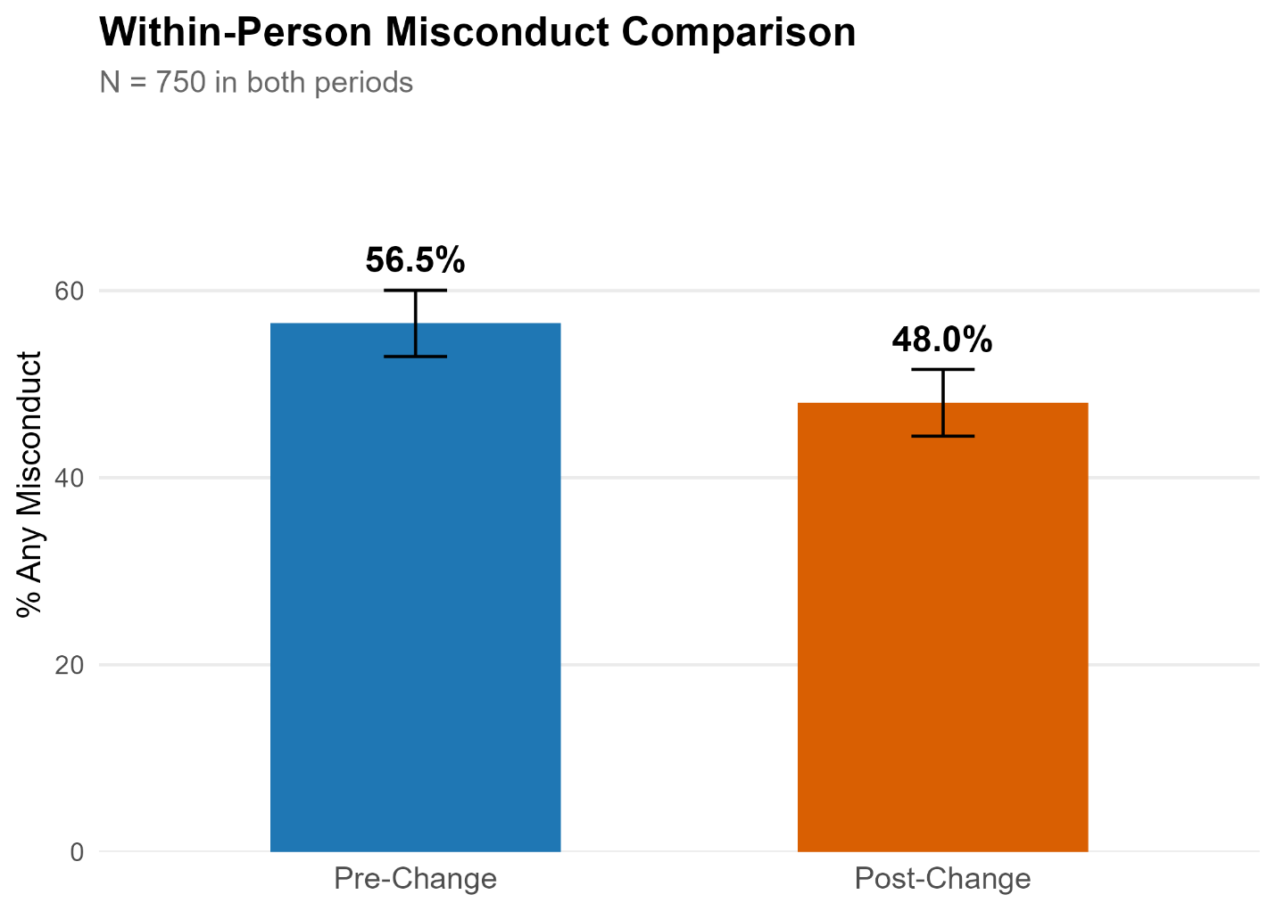

Note. Paired individuals classified in both periods. Non-overridden only. Error bars show 95% Wilson CIs.

Misconduct Concentration (Pareto Analysis)
An important question for interpreting overall misconduct trends is whether changes in aggregate rates reflect broad shifts in behavior across the classified population or whether they are driven by a small number of individuals with repeated infractions. The Pareto analysis examines the distribution of misconduct event counts among non-overridden classifications. In the pre-revision period, 49.4% of classified individuals had zero misconduct events during the six-month follow-up, while 8.5% had exactly one event, 5.5% had two events, 14.2% had three to five events, and 22.4% had six or more events. In the post-revision period, the distribution shifted modestly: 53.5% had zero events (an increase in the misconduct-free share), 6.7% had one event, 6.0% had two events, 13.7% had three to five events, and 20.1% had six or more events.
More specifically, about 10% of non-overridden inmates are responsible for roughly 55% of all guilty misconduct findings, and about 20% of inmates account for 77% to 80% of all events. Put differently, half of all misconduct events in each period are generated by just 8% of classified individuals (about 134 people pre-revision and 147 people post-revision), and 80% of all events come from roughly 20% of individuals. The Gini coefficient for the event distribution is 0.76 pre-revision and 0.78 post-revision, meaning misconduct is extremely concentrated and the post-revision period is, if anything, slightly more concentrated than pre-revision. This has a direct operational implication: the majority of disciplinary load at NMCD facilities is driven by a small, identifiable high-frequency subgroup, and aggregate pre/post differences in misconduct rates are sensitive to how that subgroup is distributed across levels and periods. Targeted interventions aimed at the top decile of event generators would, mechanically, reduce more than half of the total misconduct event load, while system-wide interventions aimed at the modal inmate would have comparatively modest effects.
Figure 20. Misconduct Concentration By Clustering
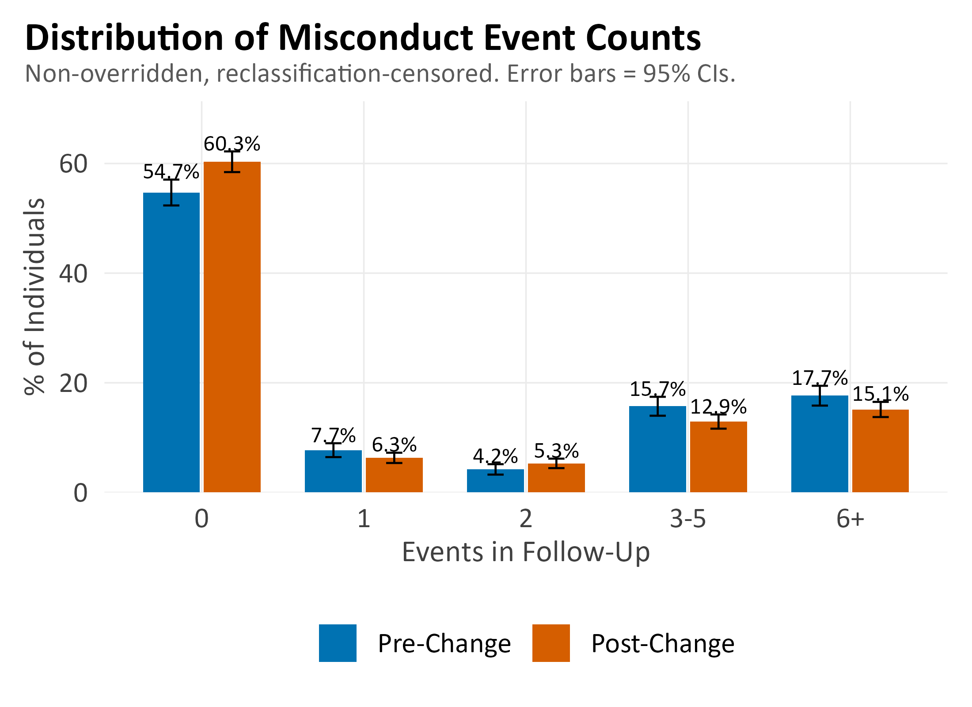
Note. Non-overridden classifications. Error bars show 95% CIs. Percentages shown above error bars.
Figure 21 presents the same misconduct concentration data as a Lorenz curve, which is a more conventional way to visualize inequality in the distribution of events. The diagonal line represents perfect equality (i.e., each individual contributing the same number of events); the further the actual curve deviates from this diagonal, the more concentrated misconduct is among a small subset of individuals.

Figure 21. Lorenz Curve of Misconduct Concentration
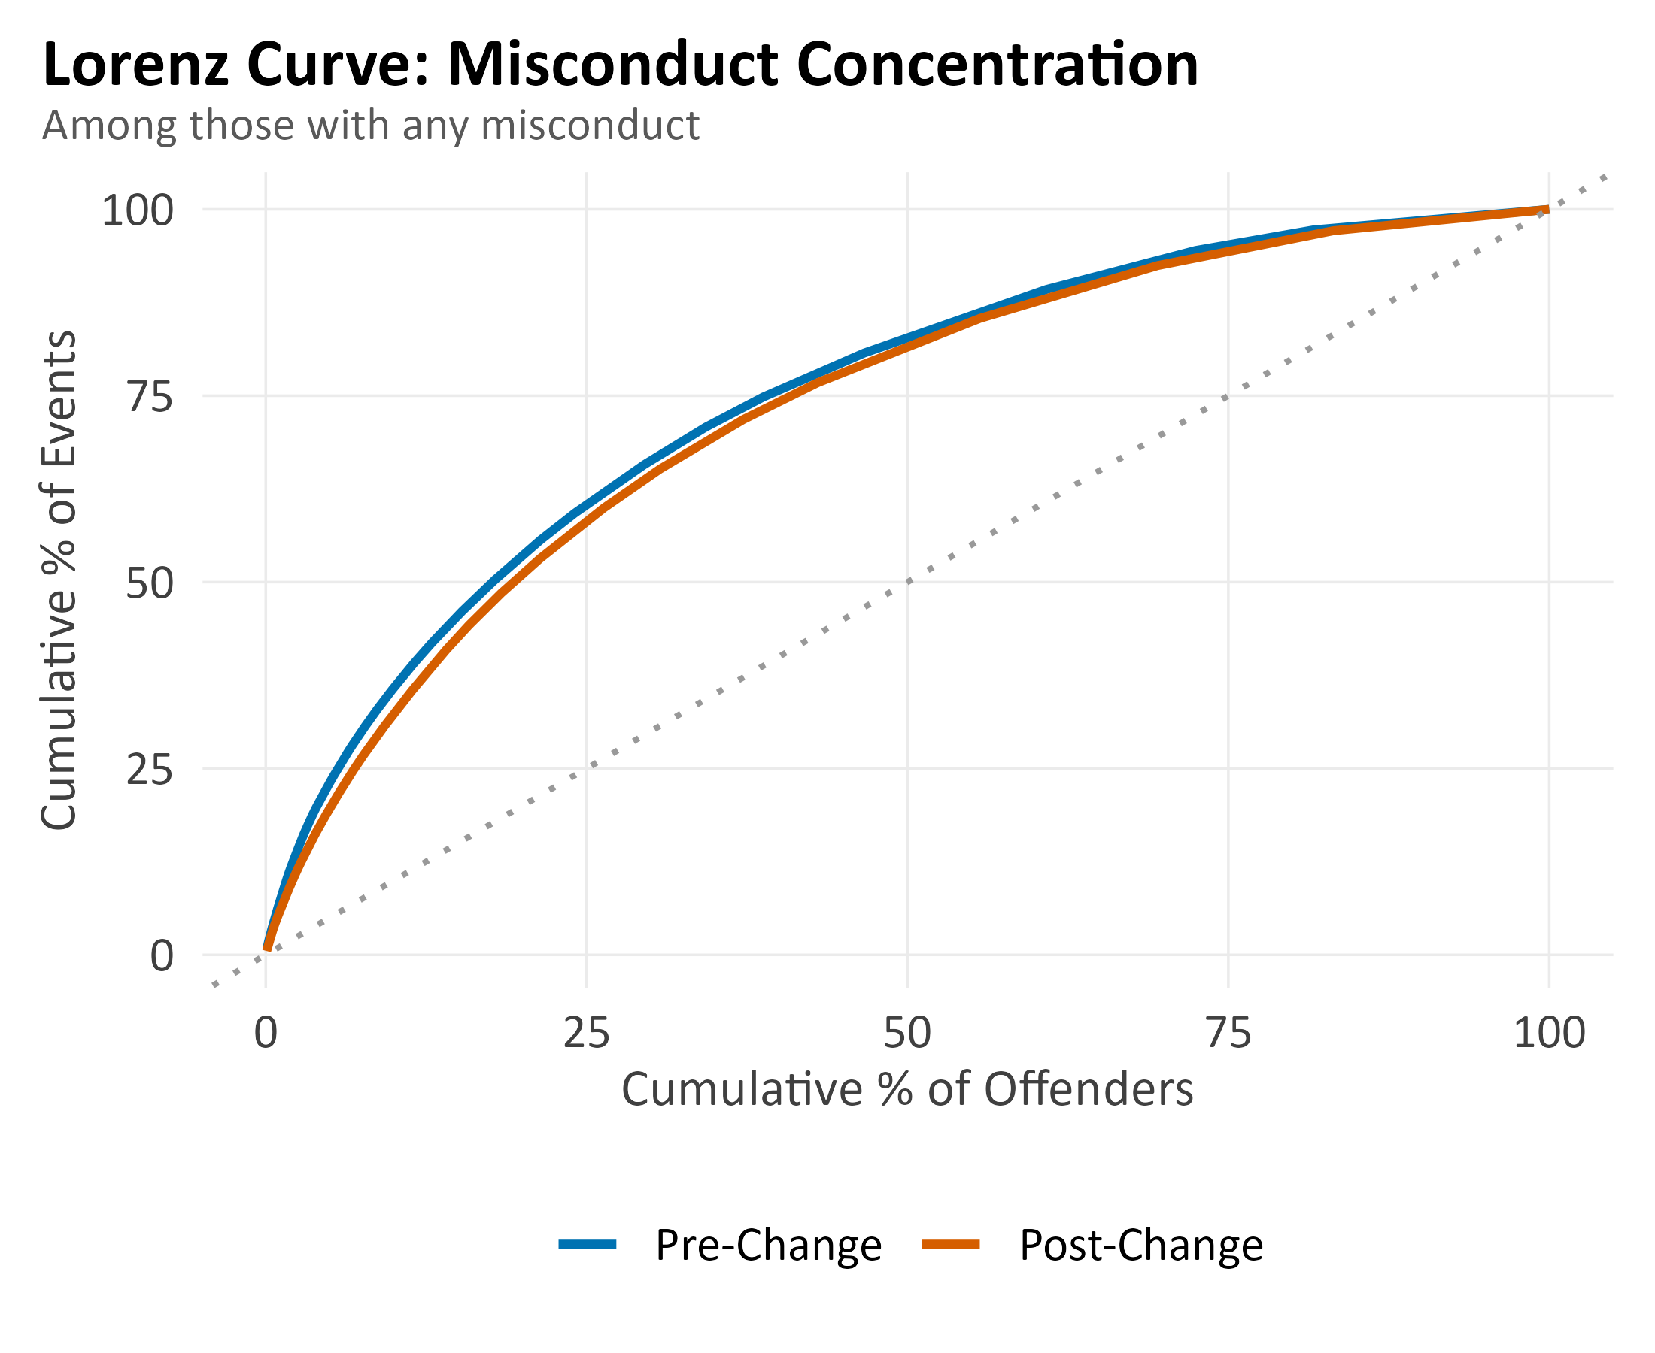
Note. Among those with any misconduct only. Dashed line = perfect equality. Farther from diagonal = more concentrated.
To unpack where this concentration sits within the custody structure, we also examined the custody-level distribution of the top decile of event generators (i.e., individuals with 19 or more guilty misconduct findings across the 18-month window, N = 360). Their modal final custody level is Level III (n = 131 people) or Level II (n = 118), with smaller concentrations at Level IV (n = 78) and Level I (n = 33). Stated as a share of classifications at each level, top-decile individuals account for 5 to 6% of Level I events, 15 to 17% of Level II events, 20 to 24% of Level III events, and 25 to 36% of Level IV events, rising steeply with custody level, and rising further in the post-revision period at Levels III and IV. The share of the event burden (rather than classifications) contributed by these individuals is substantially larger: for example, at Level IV post-revision, top-decile individuals account for roughly 36% of classifications but generate about 65% of the guilty findings. This sharpens one of the observations from Figure 14: the elevated event rate at Level IV is driven disproportionately by a small high-frequency subpopulation rather than by broader Level IV misbehavior.

Figure 22. Concentration of Misconduct Among High-Frequency Event Generators (Top 10%), Pre-Revision vs. Post-Revision
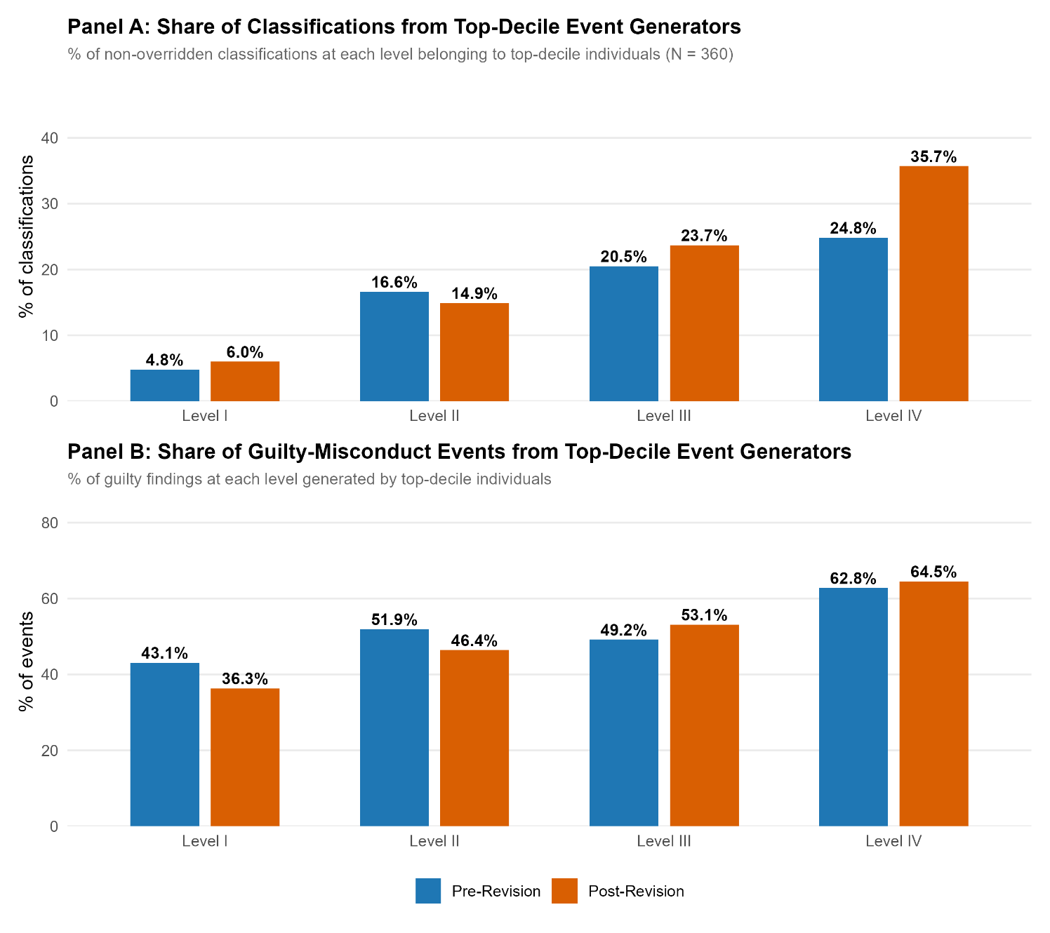
Note: Top-decile individuals (N = 360) are the 10% of the non-overridden cohort with the largest number of guilty misconduct findings across the 18-month study window (threshold: 19 or more events per person). Panel A shows the share of non-overridden classifications at each final custody level belonging to these individuals; Panel B shows the share of guilty-misconduct events at each level contributed by them. At Level I, top-decile individuals account for roughly 5 to 6% of classifications but generate over a third of Level I events; at Level IV, they account for a quarter to a third of classifications and generate roughly two-thirds of events.
A natural follow-up is whether our main pre-post comparisons are driven by this subpopulation. We re-ran the core analyses (e.g., level-stratified misconduct rates and adjusted logistic regression) after excluding top-decile individuals entirely. The direction and approximate magnitude of every main result held up: post-revision any-misconduct odds remained roughly 24% lower after adjustment (OR = 0.76 [0.68, 0.84]), post-revision serious-violent odds remained roughly 20% lower (OR = 0.80 [0.67, 0.96]), and the level-stratified pattern (Level I and Level IV rates higher post, Level II and Level III lower) was reproduced in the trimmed cohort. One result changes meaningfully: the adjusted serious-misconduct odds ratio moves from 0.88 (p = .02) in the full cohort to 0.90 (p = .09) in the trimmed cohort, indicating that the post-revision reduction in serious misconduct specifically is partly carried by the top-decile subpopulation and does not reach conventional statistical significance once they are excluded. The broader takeaway is that misconduct concentration matters for interpreting what the aggregate pre-post differences represent, but the main directional findings in this report are not strictly artifacts of the high-frequency subpopulation.

Limitations
Our study has several important limitations that should be considered when interpreting the findings:
- Selection into the non-overridden sample: The most consequential limitation is that most analyses are restricted to non-overridden classifications, that is, cases in which the score-based custody level was accepted as the final custody level. With override rates of 59.5% in the pre-revision period and 56.8% in the post-revision period, the non-overridden sample represents approximately 28% of pre-revision and 45% of post-revision classifications. Importantly, the composition of the non-overridden group changed substantially between periods, as mandatory override rates fell from 50.2% to 38.3% following the revision. The two non-overridden samples are drawn from different subpopulations. The pre-revision sample consists of roughly 28% of individuals whose scores fell within the narrower pre-revision threshold ranges and who did not trigger any mandatory override rules, while the post-revision sample represents a broader 45% of individuals classified under the wider post-revision thresholds and with fewer mandatory override triggers. This asymmetric selection threatens the pre-post comparisons in the report, because observed differences in outcomes could reflect differences in who enters the non-overridden sample rather than differences caused by the scoring revision itself. We attempt to address this through inverse probability of treatment weighting and through the strict MH-only contrast in the mental-health override analysis, but neither adjustment can fully reconstruct the counterfactual that would have been visible had override rates remained constant across periods.
- Simultaneous policy changes and limits on causal identification. The June 2024 policy change bundled multiple modifications that went live on the same date, including the scoring revision itself, a unified threshold scale, and a relaxation of mandatory override rules. We attempted to disentangle these components by examining tool-level and override-type outcomes separately and by focusing analyses on non-overridden classifications, but the design cannot cleanly isolate the effect of any single change because the changes were implemented simultaneously and were not independent of one another. Because of this, any observed post-revision difference in misconduct, override behavior, or tool performance reflects the joint effect of the full bundle of policy modifications rather than the scoring revision in isolation. This limits the strength of causal claims we can make about the scoring revision specifically.
- Window size and statistical power. The 18-month symmetric window centered on the June 2024 revision was chosen to isolate the immediate effect of the policy change and to avoid contamination from earlier policy regimes, but it limits the sample size available for certain subgroup analyses and stability checks. Sample sizes at the intersection of sex, custody level, and period are especially constrained (e.g., female inmates at Level IV are represented by small numbers in both periods, which precludes reliable sex-stratified analyses at that level), and we cannot evaluate with the current window whether the findings would replicate over a longer horizon. The stability of these estimates over time is best assessed through rolling replications in subsequent validation cycles.
- Measurement of mental-health status. The mental-health designation used throughout the report is a point-in-time acuity indicator drawn from NMCD's health services scale and not a longitudinal or diagnostic measure. It captures whether the individual was flagged for mental-health services and does not distinguish among clinically different conditions with different behavioral profiles, nor does it speak to the duration, severity, or treatment status of any underlying diagnosis. Because of this, findings that involve the MH flag should be read as population-level summaries across a mixed group, and the absence or presence of an aggregate MH-level association in these data does not rule out meaningful diagnosis-specific relationships that a more granular classification of mental-health status would reveal.
- Facility-level mechanisms. Misconduct rates vary substantially across correctional facilities, and those differences could reflect variation in staffing-to-inmate ratios, programming availability, service provision, or institutional culture. We address facility-level confounding by including fixed effects for all major facilities (each with n ≥ 100 classifications) in the regression models, and the facility effects are jointly significant (χ²(14) = 31.90, p = .004). Fixed effects control for any time-invariant facility characteristic, so facility-level confounding of the period effect is not a major concern. What the data do not allow us to evaluate is the specific mechanisms by which facility-level characteristics might moderate the relationship between classification and misconduct, because we do not have information on staffing ratios, program-participation intensity, or the mix of therapeutic and security programming at each facility within the study window. A related limitation is that custody level and facility do not fully determine the actual housing environment in which an inmate resides. NMCD facilities may operate individual housing units calibrated to different custody levels than the facility designation itself (for example, Level III-style housing units within a facility classified as Level II), and unit-level housing assignment is not available in the current data extracts. If within-facility housing assignments are correlated with individual risk profile, with tool type, or with period, they could account for some of the residual variation in misconduct that facility fixed effects alone do not absorb.
- Unmeasured confounders: Our adjusted analyses control for a limited set of observed covariates (e.g., age, gender, total score, assessment type). Important unmeasured factors that could influence misconduct include substance use history, prior incarceration history, gang involvement beyond the binary classification item, facility-specific conditions, and contemporaneous policy changes. Our causal interpretation of any residual period effect depends on the assumption that these unmeasured factors are balanced between periods, an assumption that cannot be tested with the available data.

Recommendations
- Maintain the revised scoring instrument. The June 2024 revision to the initial and maintained and modestly improved predictive validity (AUC: 0.589 → 0.613 for any misconduct on the reclassification tool), in an environment with reduced override rates. There is no evidence that the revision caused an aggregate-level increase in misconduct.
- Monitor and evaluate discretionary override practices. Discretionary overrides increased from approximately 10% to 22% post-revision. While some increase may reflect appropriate staff judgment, the pattern of overridden individuals having substantially lower misconduct at their destination level suggests some overrides may be unnecessary. Targeted training and periodic audits of override decisions can help ensure consistency.
- Monitor downward overrides at Level I. While admittedly rarer relative to other types of discretionary overrides, downward-overridden individuals at Level I (i.e., inmates who scored at Level II or III who were discretionarily downward overridden into Level I facilities) had significantly higher misconduct than score-placed individuals, suggesting staff are occasionally placing inmates in less restrictive custody than their risk warrants. Review criteria for downward overrides and consider tightening approval requirements.
- Monitor Level I crowding effects. The revised scoring substantially increased the number of individuals classified as Level I. If Level I facilities are housing significantly more people post-revision, the increase in misconduct at Level I may reflect environmental conditions (e.g., crowding, staffing ratios) rather than misclassification. Population monitoring and potential staffing adjustments at Level I facilities may be warranted.
- Continue regular validation cycles. Classification instruments should be revalidated periodically as population demographics, sentencing practices, and facility operations change. We recommend validation studies at regular intervals to ensure the instrument remains calibrated to the current NMCD population.
- Evaluate Level I compositional changes through programming and service capacity. The Level I misconduct increase appears to be driven by two overlapping compositional shifts: the doubling of serious mental health prevalence (from 9.9% to 30.1%) following the reduction in mandatory mental health overrides, and the inclusion of younger individuals through the expanded age scoring and threshold widening. Both shifts are consistent with the objectives of the June 2024 revision and our prior recommendations to reduce unnecessary overrides. However, the behavioral consequences of these compositional changes highlight the need to align Level I facility resources with the current Level I population profile. Specifically, we recommend: (a) expanding mental health programming and crisis intervention capacity at Level I facilities to match the current mental health acuity distribution; (b) implementing enhanced orientation and substance use programming targeted at young initial-classification Level I individuals, who have misconduct rates exceeding 50%; (c) monitoring Level I misconduct rates by age group and mental health status as specific quality indicators; and (d) evaluating whether a modest threshold adjustment (e.g., lowering the Level I ceiling from 8 to 7 points) meaningfully improves safety outcomes without disproportionately affecting individuals classified primarily on the basis of age.

Conclusions
In this report, we evaluated whether the June 3, 2024, revision to NMCD's classification scoring tools was associated with changes in override behavior, predictive validity, and observed misconduct among classified inmates. Using an 18-month symmetric window centered on the revision and a cohort design with 183-day reclassification-censored follow-up, we analyzed more than 22,000 classification events from 6,594 unique individuals across both the initial and reclassification instruments. The analyses combined regression with sequential adjustment and cluster-robust inference, item- and tool-level AUC analysis, random forest variable importance, survival modeling, and a within-person longitudinal comparison of individuals observed in both periods, in order to provide a multi-angle view of how the revised scoring and the accompanying override-policy changes have affected classification behavior, the instrument's discrimination, and post-classification misconduct.
Taken together, the evidence suggests that the post-revision period has, at least through December 2025, been associated with measurable changes in how the classification instrument functions, most of which are consistent with the stated goals of the revision. The reclassification tool's predictive validity improved across all three misconduct outcomes (e.g., AUC for any misconduct rose from 0.561 to 0.624; for serious misconduct, from 0.559 to 0.604; for serious violent misconduct, from 0.583 to 0.606; all DeLong p < .001). By the Desmarais and Singh (2013) benchmarks we discussed, the reclassification tool moved from the lower end of the "fair" range into its upper end, approaching the "good" threshold of 0.64. For a tool of this type, and in the context of the short post-period observation window, this represents a substantive improvement in the tool's ability to distinguish higher- from lower-risk individuals and is consistent with the revised item weights discriminating more effectively than the pre-revision weights did.
The pre-revision Level III/IV inversion, in which Level IV had a lower any-misconduct rate than Level III, has been resolved; Level IV now sits above Level III (50.8% vs. 48.4%), producing a monotonic custody-level gradient rather than the inverted one observed before the revision. Mandatory overrides declined from 50.2% to 38.3% overall and from 65.0% to 42.7% on the initial tool, indicating that a larger share of placements have recently been determined by the scored instrument rather than by rules-based adjustments.
No adjusted analysis indicates an aggregate post-revision increase in misconduct. After adjustment for measured covariates, the odds of any misconduct were approximately 25% lower post-revision than pre-revision (OR = 0.748 [0.669, 0.837]), with similar-magnitude reductions for serious and serious violent outcomes. These are statistical associations conditional on observed characteristics rather than causal effects. A complementary interrupted time-series analysis of the monthly trajectory shows a directionally consistent drop in level around the revision date (−5.5 percentage points, p = .159). While this estimate does not reach conventional statistical significance on its own, given the 18-month post-period window, its magnitude exceeds the change observed at each of three placebo dates tested within the pre- and post-periods, which strengthens the temporal association between the revision and the observed shift. Because several policy modifications went live on the same date (e.g., mandatory override rules, which could plausibly have been expected to elevate observed misconduct), the absence of a broad-based increase suggests that the combined package of changes was not destabilizing in the short-term.
The most visible aggregate change, a roughly 10-percentage-point increase in Level I any-misconduct (19.8% to 29.2%), reflects compositional change in who is now classified at Level I rather than a behavioral change in the individuals already there. The post-revision Level I population is approximately three times larger than its pre-revision counterpart and includes a substantially higher share of individuals with documented mental-health designations (30.1% vs. 9.9%) and of younger individuals, both of which are associated with elevated misconduct risk. These shifts follow mechanically from the scoring revision itself. Subsequent validation cycles should pair instrument-level monitoring with facility-level monitoring of Level I operational indicators, so that questions about how the new Level I population interacts with Level I housing, programming, and supervision can be evaluated with appropriate data.
The initial classification tool did not show the same predictive validity improvement as the reclassification tool, and among its scored items, the age factor performs most of the predictive heavy lifting, while the remaining items contribute comparatively little. This limited discrimination at the point of initial classification is a known constraint of tools that rely predominantly on static pre-incarceration factors.
The override system remains the primary open question in interpreting the tools' performance. With total override rates above 55% in both periods, the operational classification process combines the recommendation scored with staff judgment, and because we observe misconduct only at the actual placement rather than at a counterfactual score-based placement, what the instrument would have produced in the absence of overrides is not directly observable. Beyond this measurement limit, the high override rate produces a population-mixing pattern worth continued attention. At Levels II and III, a substantial share of individuals were overridden upward from a lower score-based level, and these upward-overridden individuals showed lower 183-day any-misconduct rates at their destination level than individuals who scored there directly.
Overall, the June 2024 revision introduced changes at the tool level that are largely consistent with the redesign's stated objectives. The reclassification tool's predictive discrimination improved, moving its predictive validity from the lower end of the "fair" range to near the "good" threshold on the Desmarais and Singh (2013) scale. The share of facility placements carried by mandatory overrides declined, and the observed custody-level gradient became monotonic rather than inverted. These changes occurred without a broad-based increase in observed misconduct, despite the simultaneous relaxation of mandatory override rules that could plausibly have been associated with movement in the opposite direction. However, some findings temper this summary. The initial classification tool did not show a comparable improvement in predictive validity and, in practice, functions as a largely age-based instrument, with age carrying most of the discriminative signal and the remaining scored items contributing comparatively little. A Pareto-style concentration of misconduct is also evident, with a small subset of individuals accounting for a disproportionate share of guilty findings, particularly at Level IV, where the top decile of event-generators produces approximately two-thirds of all observed events. The analyses additionally identified operational questions, particularly at Level I and with respect to the override system, that the current data can describe but cannot fully resolve. These questions warrant further examination in the next validation cycle, ideally in combination with facility-level operational and service-delivery data that would permit direct assessment of environmental and capacity factors that fall beyond the scope of the present analyses.

References
Alexander, J., & Austin, J. (1992). Handbook for evaluating objective prison classification systems. Washington, DC: U.S. Department of Justice, National Institute of Corrections.
Austin, J. (1998). Objective jail classification systems: A guide for jail administrators. Washington, DC: U.S. Department of Justice, National Institute of Corrections.
Baggio, S., Peigné, N., Heller, P., Gétaz, L., Liebrenz, M., & Wolff, H. (2019). Do overcrowding and turnover cause violence in prison? Frontiers in Psychiatry, 10, 1015.
Desmarais, S. L., & Singh, J. P. (2013). Risk assessment instruments validated and implemented in correctional settings in the United States (Tech. Rep.). Lexington, KY: Council of State Governments Justice Center. Retrieved from https://csgjusticecenter.org/ wp-content/uploads/2014/07/Risk-AssessmentInstruments-Validated-and-Implemented-in-Correctional-Settings-in-the-United-States.pdf
Duwe, G. (2020). The development and validation of a classification system predicting severe and frequent prison misconduct. The Prison Journal, 100(2), 173–200.
Duwe, G., Clark, V., & McNeeley, S. (2023). Does criminal thinking predict prison misconduct? An evaluation of TCU’s Criminal Thinking Scales. Criminal Justice and Behavior, 50(6), 830–848.
Fazel, S., Burghart, M., Fanshawe, T., Gil, S. D., Monahan, J., & Yu, R. (2022). The predictive performance of criminal risk assessment tools used at sentencing: Systematic review of validation studies. Journal of Criminal Justice, 81, 101902.
Felson, R. B., Silver, E., & Remster, B. (2012). Mental disorder and offending in prison. Criminal Justice and Behavior, 39(2), 125–143.
Houser, K. A., Belenko, S., & Brennan, P. K. (2012). The effects of mental health and substance abuse disorders on institutional misconduct among female inmates. Justice Quarterly, 29(6), 799–828.
Labrecque, R. M. (2022). Security threat management in prison: Revalidation and revision of the Inmate Risk Assessment for Segregation Placement. The Prison Journal, 102(1), 64–87. https://doi.org/10.1177/00328855211069150
Logan, M. W., Long, J., DeLisi, M., & Hazelwood, A. R. (2023). Serious, violent, and chronic prison misconduct: Are the predictors the same for women and men? The Prison Journal, 103(1), 23–44.
Long, J. S. (2020). Appropriate classification of prisoners [Doctoral dissertation, University of Cincinnati].
Schenk, A. M., & Fremouw, W. J. (2012). Individual characteristics related to prison violence: A critical review of the literature. Aggression and Violent Behavior, 17(5), 430–442.
Severson, A. (2024). Snapshot analysis of the New Mexico Corrections Department's prison population in February 2024. Center for Applied Research and Analysis, University of New Mexico Institute for Social Research. https://isr.unm.edu/reports/2024/snapshot-analysis-of-the-new-mexico-corrections-departments-prison-population-in-february-2024.pdf
Severson, A., Guerin, P., Sanchez, R., & Moore, C. (2024). New Mexico Corrections Department (NMCD) external classification validation study. Center for Applied Research and Analysis, University of New Mexico Institute for Social Research. https://isr.unm.edu/reports/2024/new-mexico-corrections-department-nmcd-external-classification-validation-study.pdf

Appendices

Appendix A. Inverse Probability Weighting Sensitivity Analysis
Because the composition of the non-overridden sample differs across periods, standard regression adjustment may not fully address selection bias. Because of this, we conducted an inverse probability of treatment weighting (IPTW) analysis as a sensitivity check on the main period effect estimates. We first fit a propensity score model predicting period (post-revision versus pre-revision) as a function of age, gender, race, tool type, score-based custody level, facility, and serious mental health status. We then calculated stabilized inverse probability weights and trimmed extreme values to the [0.1, 10] range. The effective sample size after weighting was 1,789 in the pre-revision period and 2,260 in the post-revision period.
The IPTW analysis is consistent with the central finding of the standard-adjusted models. The IPTW-weighted period effect on any misconduct is OR = 0.865 (p = .065, cluster-robust), directionally consistent with the standard adjusted estimate of OR = 0.748 [0.669, 0.837]. The IPTW estimates for serious misconduct (OR = 1.046 [0.922, 1.187]) and serious violent misconduct (OR = 1.005 [0.838, 1.205]) are also consistent with the standard adjusted analyses and indicate no detectable period effect after balancing the comparison groups on observed characteristics. The convergence of the unadjusted (OR = 0.785), standard adjusted (0.748), and IPTW (0.865) estimates suggests a genuine reduction in misconduct in the post-revision period, with the IPTW estimate being more conservative due to the weighting approach. However, the IPTW analysis can only adjust for observed characteristics; unobserved selection on individual-level factors not captured in our covariates remains a possible source of bias.

Appendix B. Detection Bias Sensitivity (Sustained Findings)
All misconduct outcomes in this report use guilty findings only as the operational definition of misconduct, which functions as a proxy for sustained findings. Across the study window, the proportion of disciplinary incidents resulting in a guilty finding rose from 86.8% in the pre-revision period to 92.1% in the post-revision period, a 5.3 percentage point increase. Examined quarterly, the guilty finding rate rose from approximately 78% in late 2022 to approximately 94% in late 2025. This trend could reflect either stricter adjudication (which would inflate observed misconduct in the post-revision period independent of any actual behavioral change) or improved screening of frivolous charges (which would not affect the count of true misconduct events but would shift the apparent denominator). The net direction of detection bias is unclear, and we cannot fully separate it from genuine misconduct trends with the available data.

Cox survival analysis examines how quickly misconduct occurs over time, accounting for different follow-up periods. Inverse probability of treatment weighting (IPTW) rebalances the pre- and post-revision groups to make them more comparable on observed characteristics. Regression discontinuity at score thresholds compares individuals just above and below classification cutoffs to estimate the causal impact of assignment decisions. Interrupted time series (with placebo dates) evaluates whether trends in misconduct changed at the time of the revision, while checking that similar “effects” do not appear at false dates. Within-person McNemar comparisons assess changes for the same individuals before and after the revision, focusing on shifts in classification or outcomes. Pareto/Lorenz concentration analyses examine whether misconduct is more concentrated among higher-risk individuals.
A cohort-based design means that we group individuals based on when they enter the study (i.e., when they are newly classified) and then follow each person forward for a fixed period of time. This helps to ensure that everyone is observed for the same length of time (i.e., six months), allowing for fair comparisons of outcomes regardless of when policy changes or other events occur.
A brief note on interpretation: odds are not the same as probability. Odds express the chance of an event occurring relative to the chance of it not occurring (odds = p / (1 - p)), so a probability of 50% corresponds to odds of 1.0, 75% to 3.0, and 90% to 9.0. An odds ratio of 1.30, therefore, means the odds of misconduct rise by 30% when moving up one custody level, but the corresponding shift in probability depends on the starting point. When baseline probabilities are low (roughly below 10%), odds and probabilities behave similarly; when baselines are higher, a given odds ratio produces a noticeably smaller change on the probability scale. Odds ratios should be read as directional and comparative statements about risk gradients, not as direct percentage-point changes in the probability of misconduct.
Several caveats apply to our use of the mental-health flag in the analyses that follow. First, the designation is a point-in-time acuity indicator (health_srvc_scale ≥ 1 at the time of classification) rather than a longitudinal or diagnostic measure; it captures whether the individual was receiving or flagged for mental-health services at the moment their classification was scored, and does not reflect stable traits or diagnosis-level specificity. Second, the flag aggregates across clinically different conditions. Prior research on mental disorder and institutional misconduct consistently finds that antisocial and personality disorders, and substance-use disorders, are positively associated with misconduct (and with violent misconduct specifically), whereas internalizing conditions such as depression and anxiety typically show weak, null, or even protective associations (Felson, Silver, & Remster, 2012; Houser, Belenko, & Brennan, 2012; Schenk & Fremouw, 2012). Any observed association between the aggregate MH flag and misconduct should therefore be interpreted as a population-level summary across these different subgroups; the absence of a flag-level association does not rule out meaningful diagnosis-specific relationships, and the presence of one does not imply that all MH-flagged individuals carry elevated risk.

